


Plan and manage menu-based catering
D1.HCC.CL2.06
Trainee Manual




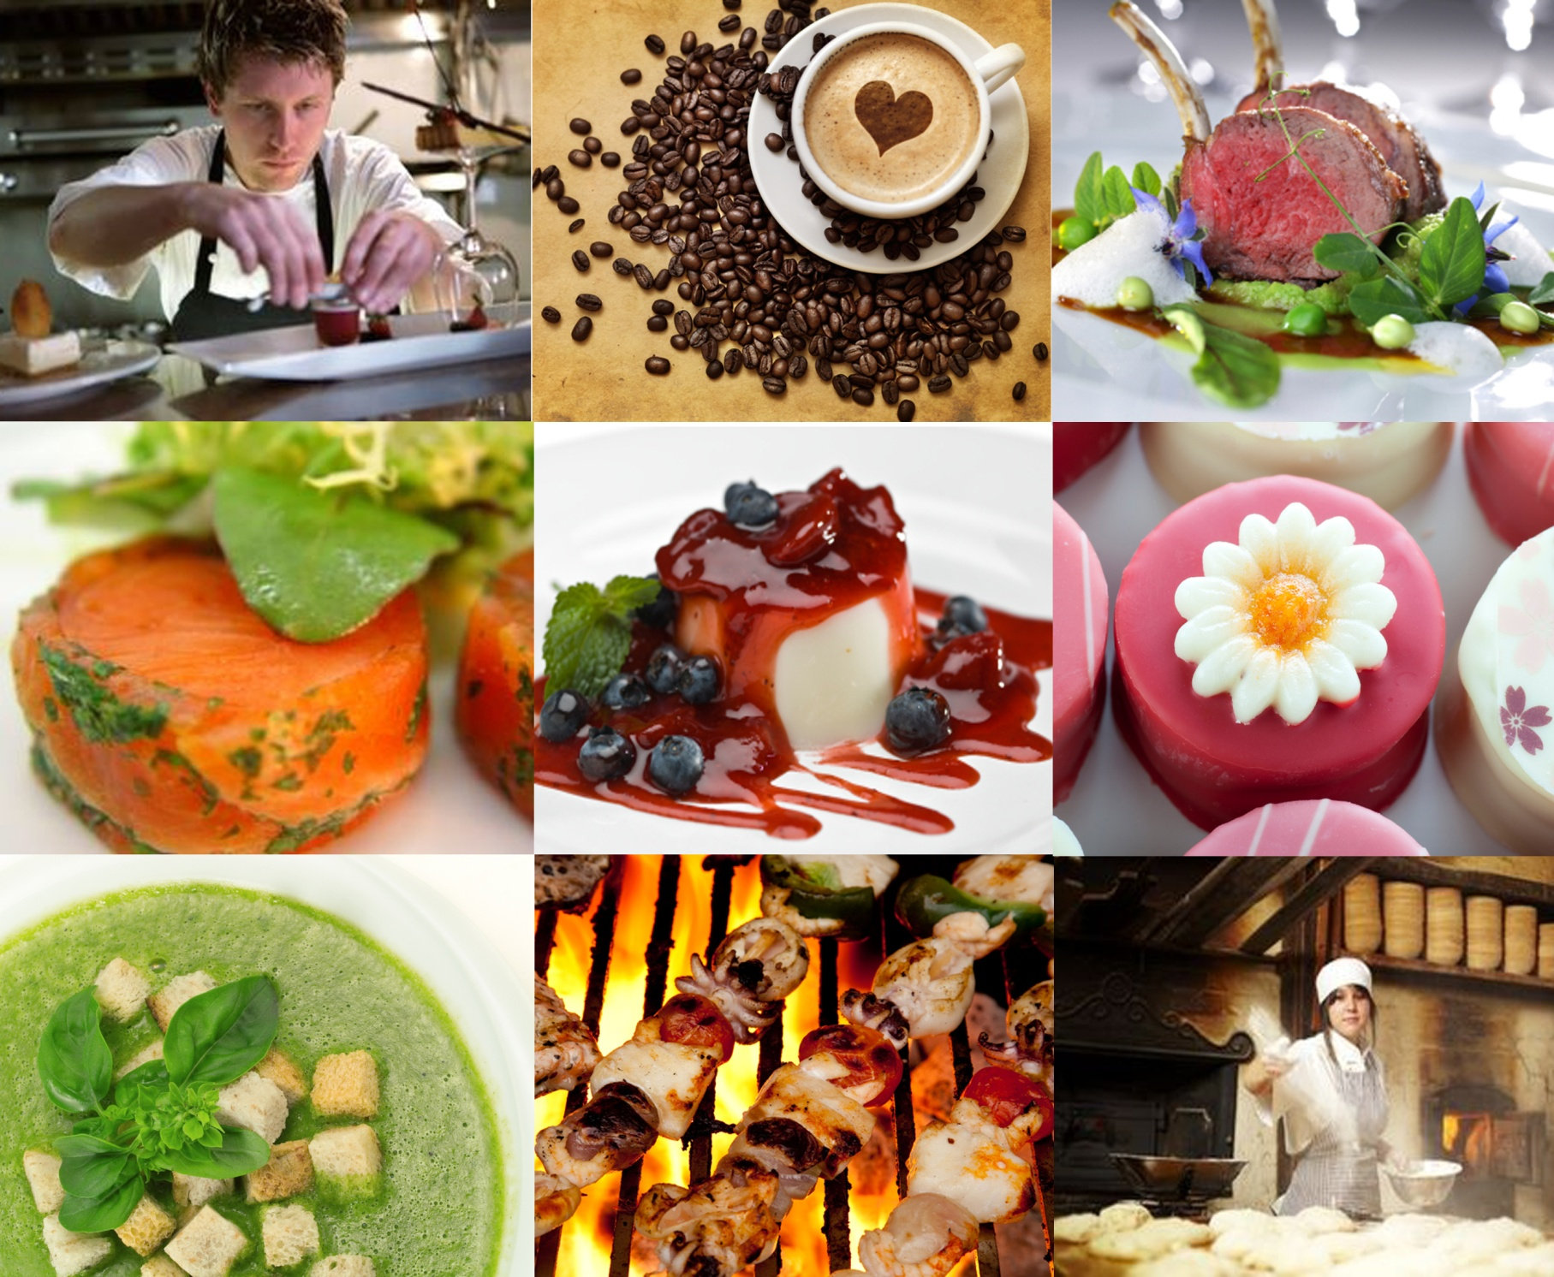

Plan and manage menu-based catering

D1.HCC.CL2.06

Trainee Manual




Project Base
William Angliss Institute of TAFE
555 La Trobe Street
Melbourne 3000 Victoria
Telephone: | (03) 9606 2111
Facsimile: | (03) 9670 1330
Acknowledgements
Project Director: | Wayne Crosbie
Chief Writer: | Alan Hickman
Subject Writer: | Garry Blackburn
Project Manager: | Alan Maguire
Editor: | Jim Irwin
DTP/Production: | Daniel Chee, Mai Vu, Kaly Quach

The Association of Southeast Asian Nations (ASEAN) was established on 8 August 1967. The Member States of the Association are Brunei Darussalam, Cambodia, Indonesia, Lao PDR, Malaysia, Myanmar, Philippines, Singapore, Thailand and Viet Nam.
The ASEAN Secretariat is based in Jakarta, Indonesia.
General Information on ASEAN appears online at the ASEAN Website: www.asean.org.
All text is produced by William Angliss Institute of TAFE for the ASEAN Project on “Toolbox Development for Front Office, Food and Beverage Services and Food Production Divisions”.
This publication is supported by the Australian Government’s aid program through the ASEAN-Australia Development Cooperation Program Phase II (AADCP II).
Copyright: Association of Southeast Asian Nations (ASEAN) 2013.
All rights reserved.
Disclaimer
Every effort has been made to ensure that this publication is free from errors or omissions. However, you should conduct your own enquiries and seek professional advice before relying on any fact, statement or matter contained in this book. The ASEAN Secretariat and William Angliss Institute of TAFE are not responsible for any injury, loss or damage as a result of material included or omitted from this course. Information in this module is current at the time of publication. Time of publication is indicated in the date stamp at the bottom of each page.
Some images appearing in this resource have been purchased from stock photography suppliers Shutterstock and iStockphoto and other third party copyright owners and as such are non-transferable and non-exclusive. Clip arts, font images and illustrations used are from the Microsoft Office Clip Art and Media Library. Some images have been provided by and are the property of William Angliss Institute.
Additional images have been sourced from Flickr and SKC and are used under Creative Commons licence: http://creativecommons.org/licenses/by/2.0/deed.en
File name: TM_Plan_&_manage_menu-base_catering_FN_030114





Table of Contents
Introduction to trainee manual 1
Unit descriptor 3
Assessment matrix 5
Glossary 7
Menus: Background, History and Trends 9
Element 1: Plan and write menus 13
Element 2: Manage menu-based catering 59
Presentation of written work 85
Recommended reading 87
Trainee evaluation sheet 89
Trainee Self-Assessment Checklist 91
Appendix 93

Introduction to trainee manual

To the Trainee
Congratulations on joining this course. This Trainee Manual is one part of a ‘toolbox’ which is a resource provided to trainees, trainers and assessors to help you become competent in various areas of your work.
The ‘toolbox’ consists of three elements:
- A Trainee Manual for you to read and study at home or in class
- A Trainer Guide with Power Point slides to help your Trainer explain the content of the training material and provide class activities to help with practice
- An Assessment Manual which provides your Assessor with oral and written questions and other assessment tasks to establish whether or not you have achieved competency.
The first thing you may notice is that this training program and the information you find in the Trainee Manual seems different to the textbooks you have used previously. This is because the method of instruction and examination is different. The method used is called Competency based training (CBT) and Competency based assessment (CBA). CBT and CBA is the training and assessment system chosen by ASEAN (Association of South-East Asian Nations) to train people to work in the tourism and hospitality industry throughout all the ASEAN member states.
What is the CBT and CBA system and why has it been adopted by ASEAN?
CBT is a way of training that concentrates on what a worker can do or is required to do at work. The aim is of the training is to enable trainees to perform tasks and duties at a standard expected by employers. CBT seeks to develop the skills, knowledge and attitudes (or recognise the ones the trainee already possesses) to achieve the required competency standard. ASEAN has adopted the CBT/CBA training system as it is able to produce the type of worker that industry is looking for and this therefore increases trainees’ chances of obtaining employment.
CBA involves collecting evidence and making a judgement of the extent to which a worker can perform his/her duties at the required competency standard. Where a trainee can already demonstrate a degree of competency, either due to prior training or work experience, a process of ‘Recognition of Prior Learning’ (RPL) is available to trainees to recognise this. Please speak to your trainer about RPL if you think this applies to you.
What is a competency standard?
Competency standards are descriptions of the skills and knowledge required to perform a task or activity at the level of a required standard.
242 competency standards for the tourism and hospitality industries throughout the ASEAN region have been developed to cover all the knowledge, skills and attitudes required to work in the following occupational areas:
- Housekeeping
- Food Production
- Food and Beverage Service
- Front Office
- Travel Agencies
- Tour Operations.
All of these competency standards are available for you to look at. In fact you will find a summary of each one at the beginning of each Trainee Manual under the heading ‘Unit Descriptor’. The unit descriptor describes the content of the unit you will be studying in the Trainee Manual and provides a table of contents which are divided up into ‘Elements’ and ‘Performance Criteria”. An element is a description of one aspect of what has to be achieved in the workplace. The ‘Performance Criteria’ below each element details the level of performance that needs to be demonstrated to be declared competent.
There are other components of the competency standard:
- Unit Title: statement about what is to be done in the workplace
- Unit Number: unique number identifying the particular competency
- Nominal hours: number of classroom or practical hours usually needed to complete the competency. We call them ‘nominal’ hours because they can vary e.g. sometimes it will take an individual less time to complete a unit of competency because he/she has prior knowledge or work experience in that area.
The final heading you will see before you start reading the Trainee Manual is the ‘Assessment Matrix’. Competency based assessment requires trainees to be assessed in at least 2 – 3 different ways, one of which must be practical. This section outlines three ways assessment can be carried out and includes work projects, written questions and oral questions. The matrix is designed to show you which performance criteria will be assessed and how they will be assessed. Your trainer and/or assessor may also use other assessment methods including ‘Observation Checklist’ and ‘Third Party Statement’. An observation checklist is a way of recording how you perform at work and a third party statement is a statement by a supervisor or employer about the degree of competence they believe you have achieved. This can be based on observing your workplace performance, inspecting your work or gaining feedback from fellow workers.
Your trainer and/or assessor may use other methods to assess you such as:
- Journals
- Oral presentations
- Role plays
- Log books
- Group projects
- Practical demonstrations.
Remember your trainer is there to help you succeed and become competent. Please feel free to ask him or her for more explanation of what you have just read and of what is expected from you and best wishes for your future studies and future career in tourism and hospitality.

Unit descriptor
Plan and manage menu-based catering
This unit deals with the skills and knowledge required to Plan and manage menu-based catering in a range of settings within the hotel and travel industries workplace context.
Unit Code:
D1.HCC.CL2.06
Nominal Hours:
30 hours

Element 1: Plan and write menus
Performance Criteria
1.1 Establish the enterprise and/or clients requirements for menu/s
1.2 Write menus for enterprise operations
1.3 Write menu ensuring menu balance
1.4 Prepare menu costing
1.5 Produce finished/final menu

Element 2: Manage menu-based catering
Performance Criteria
2.1 Select and use appropriate catering control
2.2 Control labour costs
2.3 Optimise product usage
2.4 Apply stock control measures
2.5 Plan production schedules

Assessment matrix
Showing mapping of Performance Criteria against Work Projects, Written Questions and Oral Questions
The Assessment Matrix indicates three of the most common assessment activities your Assessor may use to assess your understanding of the content of this manual and your performance – Work Projects, Written Questions and Oral Questions. It also indicates where you can find the subject content related to these assessment activities in the Trainee Manual (i.e. under which element or performance criteria). As explained in the Introduction, however, the assessors are free to choose which assessment activities are most suitable to best capture evidence of competency as they deem appropriate for individual students.
 |  |  | Work Projects | Written Questions | Oral Questions
Element 1: Plan and write menus
1.1 | Establish the enterprise and/or clients requirements for menu/s |  | 1.1 | 1, 2, 3 | 1
1.2 | Write menus for enterprise operations |  | 1.2 | 4, 5, 6 | 2
1.3 | Write menu ensuring menu balance |  | 1.2 | 7, 8 | 3
1.4 | Prepare menu costing |  | 1.3 | 9, 10, 11, 12, 13, 14, 15, 16, 17 | 4
1.5 | Produce finished/final menu |  | 1.2 | 18 | 5
Element 2: Manage menu-based catering
2.1 |  | Select and use appropriate catering control | 2.1 | 19, 20 | 6
2.2 |  | Control labour costs | 2.2 | 21, 22, 23 | 7
2.3 |  | Optimise product usage | 2.3 | 24, 25 | 8
2.4 |  | Apply stock control measures | 2.3 | 26, 27, 28, 29 | 9
2.5 |  | Plan production schedules | 2.4 | 30, 31 | 10

Glossary
Term | Explanation
Cost Control | Determining all the cost and applying it to income
Credit Note | Notice to apply credit for undelivered or faulty goods
Cuisine | Style of food, commonly applied to culture based cookery
Defect | A fault in a product
Defect | Fault in a specific product
Delivery docket | List of goods delivered
Fare | Food: old English word meaning food
Invoice | List of goods received by the customer, with prices charged
Menu | Bill of fare: list of food being offered for sale and the prices that will be applied
Order form | Copy of goods ordered
Portion Control | A standard recipe will yield a set number of serves; portion control requires that number of serves to be attained
Standard Recipe | List of ingredients and methods of cooking to produce a set quantity of food at a specific standard
Statement | Account for multiple invoices over a trading period that remain owing and unpaid
Stock take | Counting of all unused commodities that are still unsold
Table d’hôte | Table of the house; what the restaurant is offering today
Yield testing | How much usable product is obtained from a set amount? How many slices of cake can be obtained from a 12 inch Chocolate cake?

Menus: Background, History and Trends

What is a Menu?
A pure dictionary definition lists the word menu as a “bill of fare” or a list of dishes served.
It does, however, serve other purposes. It is an ideal tool in the following areas:
- Communication: by advertising exactly what an establishment can offer its customers, as well as assisting the staff preparing the food
- Selling: by enticing a customer to buy a particular dish
- Advertising: through the development of a reputation for culinary specialties and/or quality
- Public Relations: creating a focus on the establishment as well as awareness in the minds of customers, e.g. a customer may encourage his/her friends to visit a particular establishment because he/she has heard that “the seafood is always fresh”.

Background History
Contrary to popular opinion, the concept of offering a “list of dishes” (or menu) to customers did not originate in France, or even Europe for that matter, but rather China.
Marco Polo noticed in his travels (around 1280) that the city of Hangchow had restaurants which specialised in particular foods.
These foods were offered verbally to the customer and when they had made a choice; their order was verbally relayed to the kitchen for preparation and subsequent service.
One of the first known references to menus in Europe was made in the 1541 when Duke Henrich von Braunschweig attended a banquet at the Reichstag I Prussia, and later commented about a “slip of paper” that the chef had given him which described the dishes in order to allow the duke to choose a dish.
In Europe, particularly France, menus of that period were predominantly bills of fare in the literal sense i.e. list of dishes.
All foods were placed on the table and eaten without attention to balance or sequence.
Towards the late 1700s/early 1800s, more attention was devoted to eating food in a sequential manner instead of placing all dishes on the table at the same time.
This had a profound effect on menu writing at the time, particularly in France, where emphasis was increasingly placed on offering a balanced selection of dishes which complemented each other.
The number of cooks and chefs required to service classical French Cuisine increased proportionately with the greater number of dishes offered per course.
Elaborate centrepieces made from sugar, marzipan, salt, lard, margarine, ice or vegetable would often accompany these dishes.
During these periods which lasted approximately from the late 1700s through to the early 20th century, menus, dishes and dining concepts were considered both grand and extravagant.
Increased demand and cost of ingredients as well as labour saw the decline of the large expensive menu styles from the early to mid 20th century.
Customers were shifting towards lighter and more economical styles of eating and menus were becoming smaller, simpler and cheaper.
Coupled with the greater variety of fresh foods available, dining styles in many regions of the world have changed rapidly, particularly in the 1980s and 1990s and menu planning has reflected these trends.
It is interesting to note that the number of menus in high quality establishments exclusively written in French has diminished.
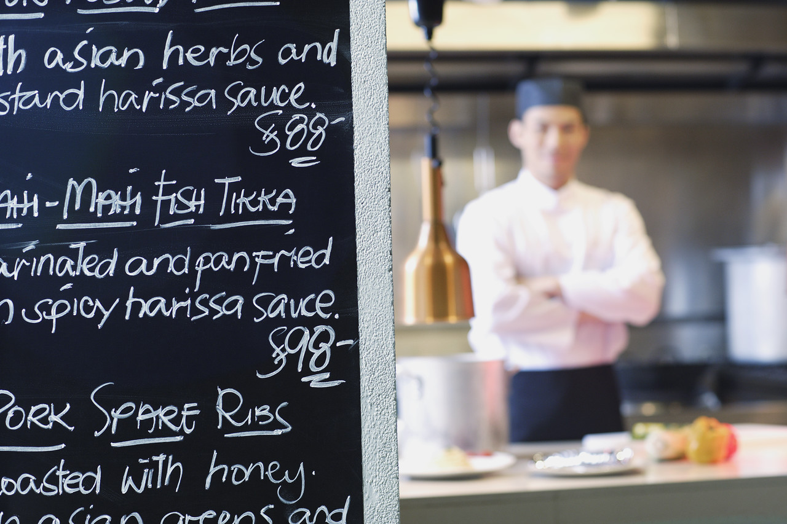

Menu Influences
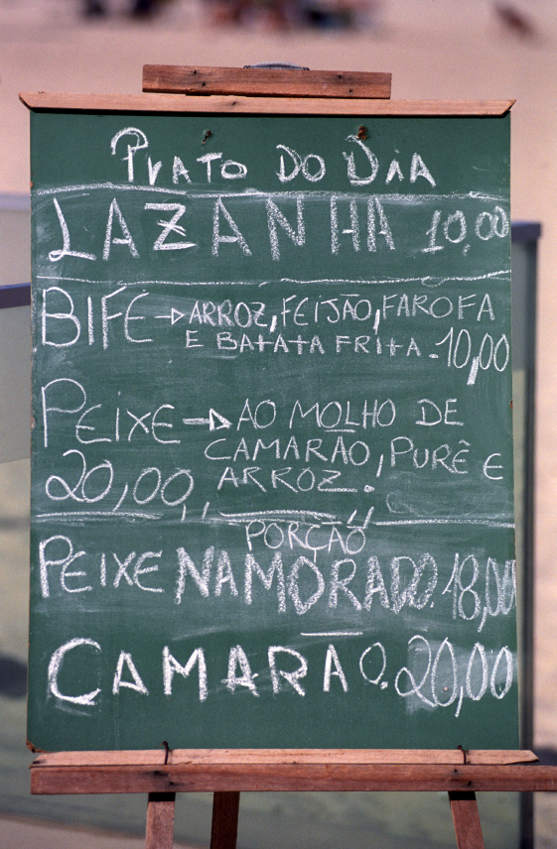
There are as many different cuisines on a global basis as there are countries, regions and customs.
Each cuisine offers a regionalised edible portrait encompassing local history, culture and religion.
These cuisines, by utilising local produce, develop dishes which are harmonious with the surrounding climate and weather.
The types of cuisines developed over the years are not limited within national boundaries, but rather climatic and cultural regions.
In France, their cuisine has developed beyond regional emphasis and more towards lighter “healthier” styles of dining.
Though most of these terms are not commonly used in most ASEAN countries, the methods of preparing them certainly are which include the following:
Traditional
European based French classical cuisine with a multi-course structure.
Modern
European in origin, and developed in the late 1950s and remained popular into the late 1970s.
Minceur
Based on the French Classic cuisine but with principles which encourage healthier cooking styles that avoid excessive fats and unhealthy styles of cooking
Naturelle
A style which an emphasis on leaving food in as natural a state as possible.
- Vegetables, for example, would be cooked minimally or not at all.
Ethnic
Ethnic cuisine by definition should embrace every cuisine that is not native to a particular area.
Each country in the world will have their own individual cuisine and each will have their own unique flavour that appeals to the individual.
The challenge of the modern day professional chef is to produce food that will satisfy a majority of consumers.
Cooking a new dish that they are not familiar with is the true test of a professional.
- How can I make this better?
With modern technology it is easier to obtain new recipes and to conduct research on new ingredients but it is difficult to teach yourself a new technique if you cannot obtain constructive feedback from an authoritative person.

Regional
A dish or cuisine from a specific geographic region, for example Mediterranean, provincial (South France), Cantonese (southern China), Szechwan (China), Pacific etc.
Contemporary cuisine styles in different countries have developed eclectically by borrowing from a number of other styles and influences.
For example, it is not an uncommon feature for several influences to feature on the same menu.
Student Activity
Look around your local area and select different enterprises that offer ‘Bills of Fare’ that meet the following criteria:
Local contemporary cuisine
Ethnic cuisine
International cuisine.
If there is terminology that the student does not understand then that is what they need to research before the activity is completed.
Students should be able to assemble six menus and each menu should be slightly different style.

Element 1:
Plan and write menus

1.1 Establish the enterprise and/or clients requirements for menu/s

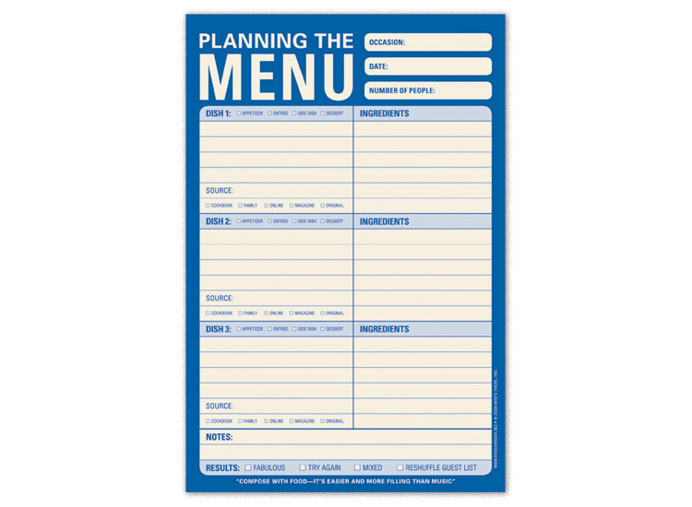
Basic menu planning structure
Consumer Requirements
Before attempting a menu planning, it is important that you understand why, when and where people prefer to dine.
The first priority of providing food has to be to satisfy hunger.
Food has, however, always been linked to other factors such as socio-economic, emotional and psychological needs.
In other words, it is also important to know how and why a customer may be motivated to select or enjoy particular cuisines or dishes.
Consumer Expectations
Expectations of consumers are difficult to pinpoint, but are nevertheless motivated by the following areas:
- Personal preference and knowledge of the diner
- Cultural or religious preferences and restrictions
- Awareness of the food being eaten
- Value for money.
Ultimately the proprietor of the enterprise makes the decision as to the market that they wish to enter. The Menu should reflect that market place and the values expected within.

Types of menus
The specific types of menus offered in establishments will depend on:
- The establishment’s hours of business
- Types of customers, and their reasons for dining
- Time constraints
- Skill of the staff.
Overall, it could be argued that menus are reasonably similar in that they offer the diner a choice of different dishes to eat.
From a structural point of view, however, they differ slightly, and can include the following types:
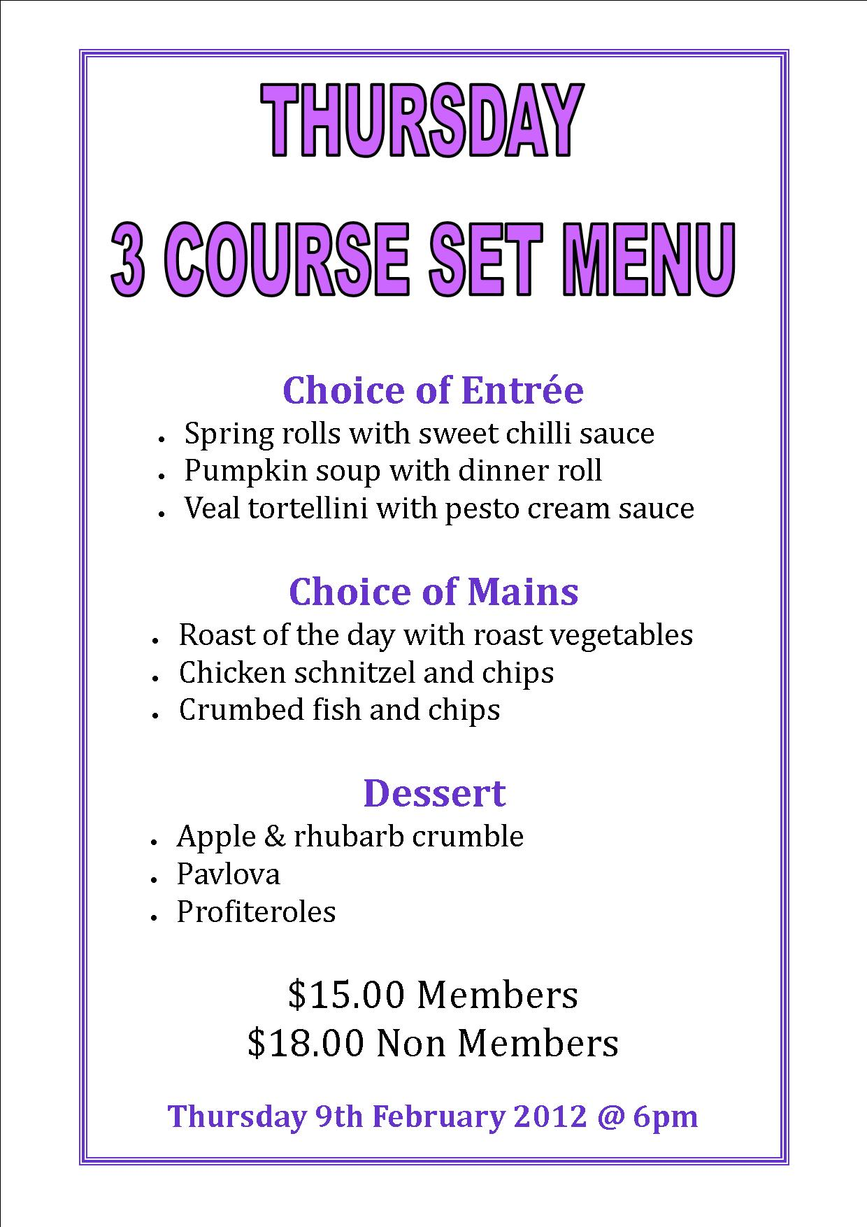
Table d’hôte
French term used to describe what is more commonly known as a set menu.
One or more dishes can be offered per course. It can also feature an all-inclusive price per person.
This type of menu also allows for some dishes to be pre-prepared, and is therefore appropriate in an environment where cost of labour and food is an issue.
Table d’hôte menus can be presented in the following ways:
- Verbally
- Menu card
- Board (chalk, illuminated, printed, etc.)
- Illustrations.
A La Carte
This term is commonly referred to, rarely applied.
To serve a true a la carte menu means that the kitchen should be preparing all dishes when ordered specifically by the customer.
In other words, cooking for a particular dish should not begin until the order is placed in the kitchen.
The concept is also expanded to suggest that the diner will create his/her own meal from the card.
As a la carte menus generally require more well-trained staff, the number of establishments offering this type of service has fallen dramatically.
A la carte menus are usually presented in a printed or written form to the diner.
Banquet
Banquet menus, also known as function menus, are similar in structure to table d’hôte menus in that they are usually menus with limited choices and fixed prices.
They are ideal for larger groups of people who intend to dine at the same time.
These functions may be celebratory, i.e.:
- Wedding
- Birthday
- Business-based conferences
- Seminars.
Dishes selected for banquet or function menus are specifically geared to satisfy the greatest number of people, and avoid (as a general rule) using exotic ingredients, or dishes that may be inappropriate from a medical or religious perspective.
Banquet menus are normally pre-organised, although menu cards are sometimes placed on the tables to indicate the menu to the diners.

Types of service
Due to the large diversity of cultures that can accumulate due to modern tourism, it can be difficult to define what should be served and when.
Many people, when they travel, want what they eat at home to be available wherever they go.
The following services should be used as an approximate guide only.
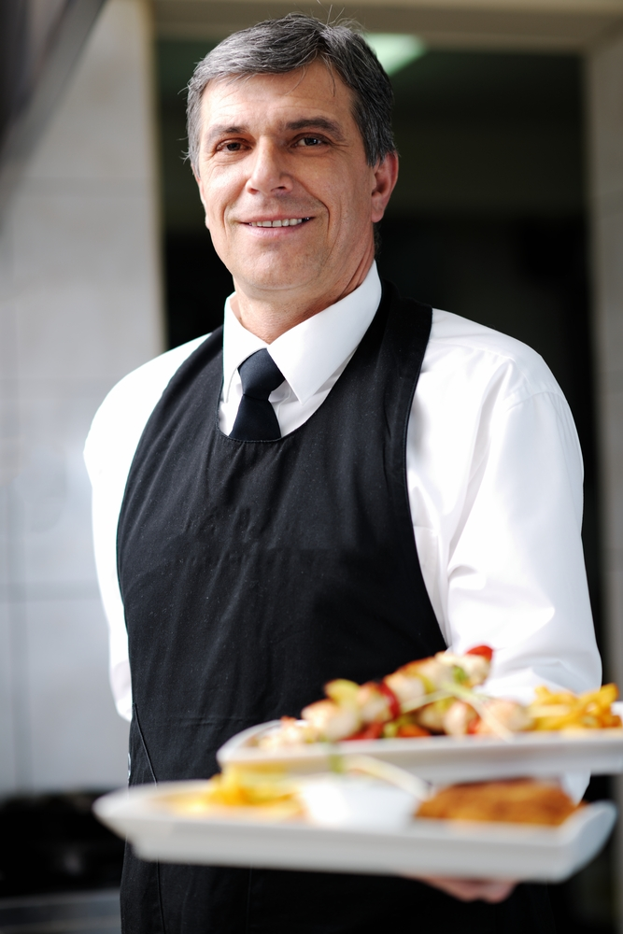
Breakfast
- Normally served from 6.00 am. - 10.00 am
- Western (European and American) styles of breakfast are broken down below.
Continental
‘Continental’ is a term used to describe what might be available in France or Germany as being from the Continental Europe as opposed to England.
Type of bread or pastry such as croissants, baguette, and toast served with a preserve or honey, finished with coffee.
English breakfast
Hot breakfast which can include fried bacon rashers, eggs (scrambled, poached or fried), grilled lamb cutlets, grilled tomatoes, fried mushrooms, kedgeree (curried fish and rice), fried kidneys, livers, toast.
The cold part of the English breakfast includes the continental breakfast as well as cereal, selection of juices, tea and/or coffee.
American
Similar to English, except hot cakes (pancakes) are also served with whipped butter, maple syrup (sometimes with bacon rashers).
Eastern
Asian styles of breakfast whilst not served in the mainstream include simple rice- based dishes such as congee (rice porridge), broths, fish, fruit, etc.
Morning Tea
Morning teas are normally served between 10.00 am - 11.00 am.
British in origin, a traditional morning tea will include a selection of sandwiches, scones with jam and cream, small cakes, pastries and fruit plates. These are accompanied by tea made in pots.
Brunch
Brunch is a combination of lunch and breakfast, and is usually served between approximately 9.00 am to12 noon.
Similar foods to an English breakfast are quite often served, although sliced meats, cheeses, and other slightly more substantial food is served.
Lunch
Lunch is normally served between 12 noon - 3.00 pm.
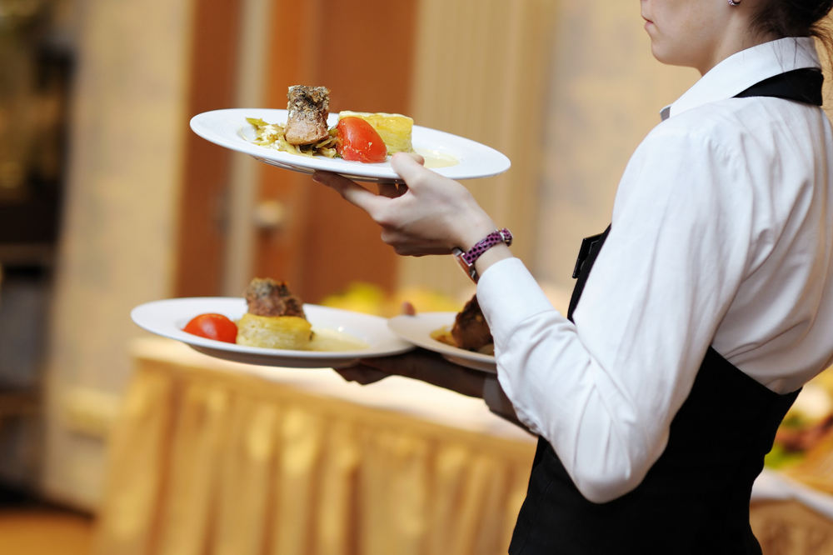
It is more often than not considered a utilitarian meal. In other words, it serves to satisfy hunger, and get the diner back to work.
From a menu planning perspective, most lunch diners are usually on tighter schedules, i.e. less than one hour.
The actual food served has to then reflect this. Few diners have more than two courses during this period.
There are no hard and fast rules governing what can or cannot be served at the lunch table, however, pasta, salads, light grills, seafood and sandwiches are popular choices.
Afternoon Tea
Served between 3.00 pm. - 5.00 pm, it is similar to morning tea, although there is sometimes more emphasis on cakes.
High Tea
High teas are served from 5.00 pm - 6.30 pm.
Rarely conducted in Australia, high teas consist of snacks, tea, cheeses, seafood or egg dishes.
Dinner
Designated the main meal of the day, dinner is normally served any time between 6.00 pm. - 10.00 pm.
More relaxed than the lunch meal, it is quite normal for diners to allocate up to three hours for dinner.
The actual dishes presented can often be more elaborate, and diners will quite often eat three, sometimes four courses in one sitting.
The type of food served is similar to the lunch menus, except meat, game and seafood main courses take greater predominance.
Supper
Is usually served from 10.00 pm, the food served is both simple and easy to prepare.
Hot and cold dishes include soufflé, sandwiches, smoked salmon, desserts, coffee, chocolates and snacks.

Customer requirements or needs
Lifestyle choices do not make people sick or have the potential to kill a person.

Allergy sufferers can potentially die from consuming foods that contain the active ingredient to which they are allergic.
- Nuts; both ground nuts and tree nuts
- Eggs and products that contain egg
- Fish and products that contain fish ingredients
- Soy and products that contain soy ingredients
- Milk and milk products
These are ingredients must be noted and customers need to be informed if they are in any of the foods that are on your menu.
Lifestyle choice of living as a vegetarian or following religious beliefs and not consuming specific foods is not necessarily going to end a person’s life.
Evolution of Terminology
As a Culinary person travels around the world they will find words being used that do not quite fit what it means in their own country.
When selling to the public there sometimes needs to be ‘a selling point’ that phrase or term that can be used to emphasise that this is different.
The TRUE Supper was originally served to factory workers when they arrived home at 6pm-7pm after their 12 hours of working and because they were poorly paid they extensiveness of the fare (food) was limited to what they could afford to buy.
Criteria: normally served to men who worked manual labour in factories; so it needed to fill them up and also replenish their body for the next day.
Cheese, 1 slice or piece of meat; plenty of bread, hot beverage; tea; to wash down the dry bread and to finish a slice of cake; ginger cake and maybe fruitcake for a special occasion.
As they standard of living increased so did the offering for supper increase.
It is now accepted that supper is a smaller menu offering that is offered after the main restaurants have ceased to trade for the evening.
So terminology used to sell a dish may not be exactly what others from other countries might call it.
That is what evolution is all about. Nothing stays the same.
The universal saying might be applied to menus.
- ‘Same same but different’.
Many of these ‘old terms’ are being made redundant due to sophisticated tourist travel and all cuisines will pick up elements of other styles from other places in the world.
The best result in the end is the production of good quality tasty food that the customer will remember as part of the overall enjoyment of dining in any establishment.

1.2 Write menus for enterprise operations

Menu constraints
Menu Length
The number of dishes offered per course as well as the numbers of courses themselves will be influenced by the following factors:
- Cost to maintain each dish on the menu
- Ready availability of ingredients
- Time available to prepare ingredients.
It makes little sense to offer dishes that either do not sell well, or are time consuming and expensive to create.
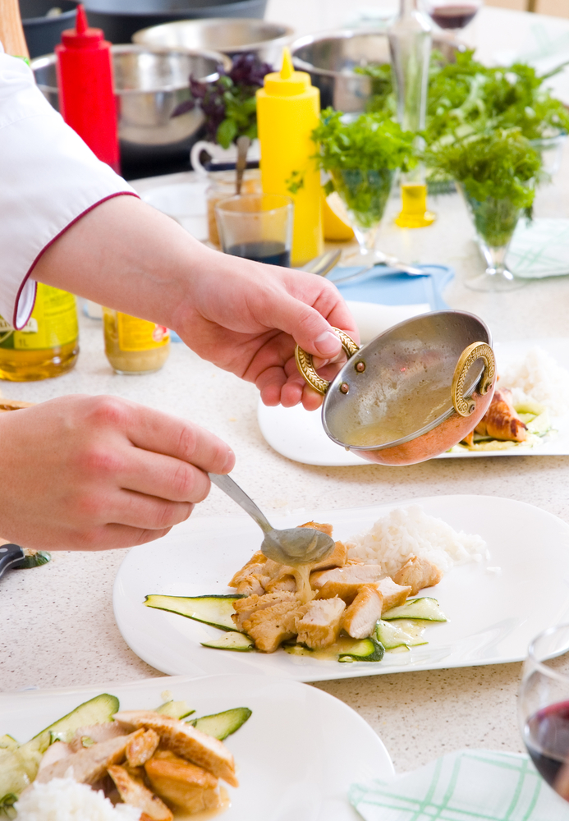
- The number of dishes offered on a menu has to be based on the above factors.
In this context, it is quite suitable for some establishments to offer up to 100 different dishes, whereas others will struggle with 20% of that number.
Most menus these days offer menus in a three or sometimes four course format. These will normally include the following:
- Starters
- Main course
- Dessert
- Cheese.
This is a considerable contrast to the French Classical menu which had anything up to 17 courses. A typical format of such a menu follows:
- Hors d’oeuvre
- Soups
- Fish
- Entrees: light meat dish
- Relevés: joint or whole bird
- Sorbet
- Roast
- Cold dishes: chaud-froid dishes
- Vegetable dishes
- Sweets
- Savouries
- Cheese
- Dessert
- Coffee.

Layout of menu
Menu layout should be appropriate to the type of establishment or situation.
For example, a leather bound multi page menu may be considered suitable in more formal dining rooms but be unnecessarily extravagant in a corner milk bar.
By the same token, a chalk board or illuminated menu would look equally inappropriate in a fine dining establishment, but be perfectly appropriate in a casual dining environment.

Modern day Western styled menus
Some of the better restaurants will have a manageable menu comparable to the number of staff in the Kitchen
Entrée
- 6 or 8 offerings.
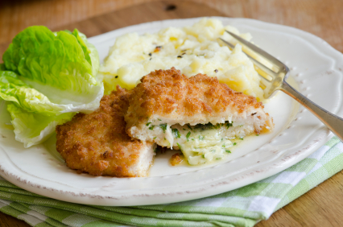
Mains
One or two of each of the main foods:
- Beef; Lamb; Chicken; Fish; Seafood; Vegetarian options.
Side orders
- Potato dish (hot)
- Green vegetable (hot)
- Salad (cold).
Desserts
- Chocolate flavoured
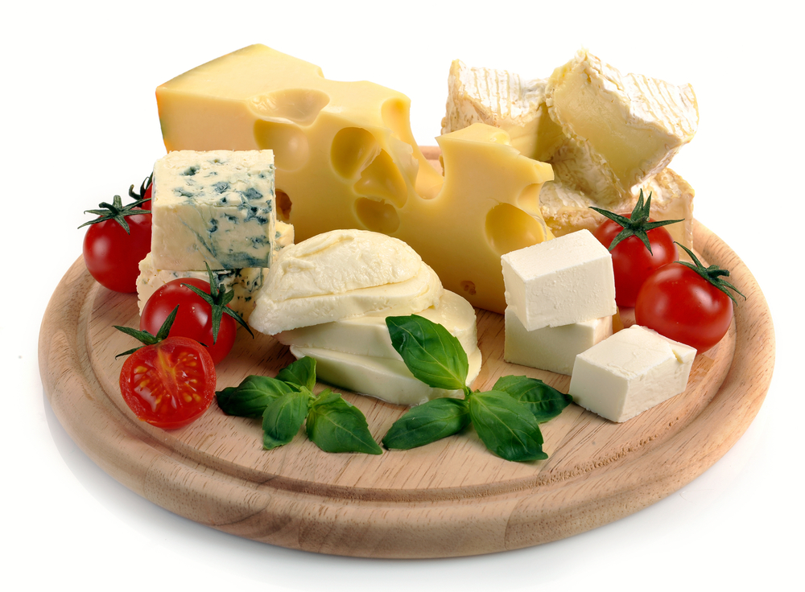
- Citrus flavoured
- Hot dessert
- Cold dessert (ice cream).
Cheese plate
- Cheddar, brie, blue cheese.
Coffee Selection

Italian style predominately but many local or regional styles may also be offered.

1.3 Write menu ensuring menu balance

Introduction
When determining the actual content of the menu – in terms of courses to be offered and in terms of dishes within each section – there is a need for ‘balance’.
Balance means many things. Balance can mean different things to different people, and different people place the emphasis on different aspects of the menu, dishes and related areas.
It can embrace:
Balance in terms of prices
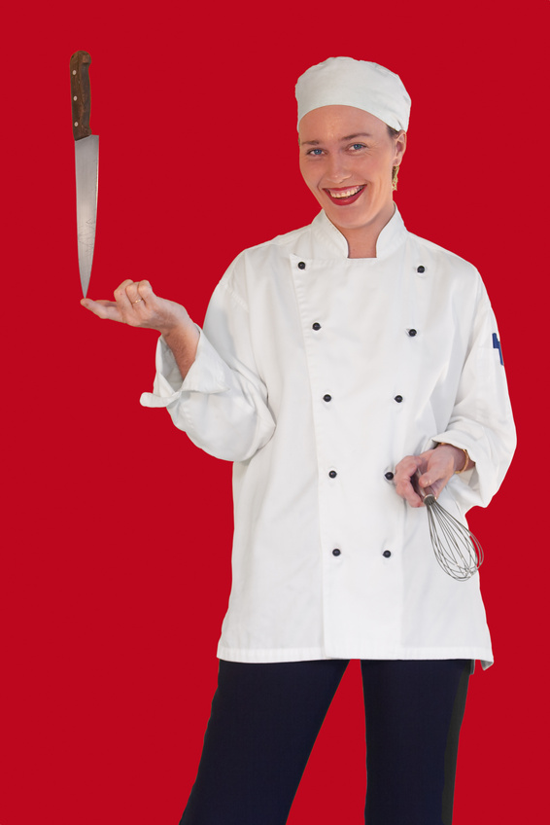
- Offering something along a variety of price points so that all pockets are catered for: bear in mind however that some venues deliberately set high prices in order to give the impression of prestige, or price out those who they may consider unworthy of, or unfit to, dine in their establishment.
Balance in terms of ingredients
- Offering something that suits everyone: where the premises is not a restaurant specialising in a certain food item such beef, seafood, vegetarian, etc., then there is a need to make sure that we provide for those who want steak, fish, chicken, pasta, etc.
Balance in terms of cooking styles
- Ensuring that not all dishes are deep fried, or grilled, but offer a selection of cooking methods to cater for personal preferences including roasts and wet dishes.
Balance in terms of complexity and simplicity
- It is great to offer menu items with complex sauces but it is also important to offer a range of items that are beautiful in appearance and tasteful to the palate by virtue of their simplicity.
Balance in terms of traditional dishes and new experiences
- Many premises will seek to provide a selection of dishes that can be seen as time-honoured along with a choice of new dishes perhaps featuring novel ingredients and fresh cooking or presentation approaches.
This is especially the case where a chef has a ‘signature dish’ that people travel long distances to experience.
Balance in terms of taste
- Presenting a variety of taste sensations that enables those seeking a spicy dish, a creamy dish, or a sour dish to be accommodated.

Final Menu
Establishments may use the following means of deciding on the final composition of their menu:
Personal likes and preferences of the owner/manager
- Some dishes will find their way onto the menu simply because the owner likes it and has always felt there is a market for it. He/she who pays the piper calls the tune!
Equipment available in the kitchen
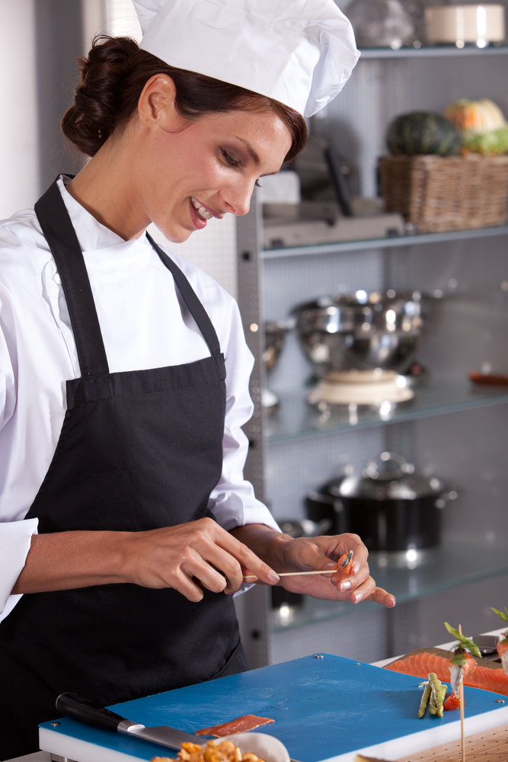
- Some dishes can’t be produced unless the right equipment is available, and very few kitchens are able to contain all items of cooking equipment.
Staff skills
- There are doubtless many dishes that require a certain level of experience and expertise: not everyone can cook everything and the industry is currently experiencing a shortage of trained and experienced chefs.
Historic records
- Previous sales will be a good indicator of what should be (kept) on your menu and what dishes could be replaced:
- A regular analysis of actual sales can be an illuminative undertaking to determine what is selling well, what isn’t and exactly how many of each item is being ordered sold.
Market research
- This can include proactive questioning of patrons:
- Simply factoring in the ‘by the way’ feedback that is received from customers at the completion of their meal, or
- As they are leaving: this can be an accurate indicator of what they think about current offerings
- What they believe should be changed.
Seasonal offering
- Enterprises will change their menus as the seasons change to offer regular variety and to take advantage of the (cheaper) items that are in season:
- Many establishments prefer a set core of menu items supplemented by ‘house specials’ that vary daily or weekly to provide variety
- Many establishments change their menu every three months
- As well as having additional special short-term menus for occasions celebrating local festivals, public holidays or religious, sporting or cultural events

Staff numbers
- More kitchen staff will generally mean more alternatives can be offered:
- Where there are very few staff this means that generic cooking styles must be used and there is less scope for the more complex dishes
- Many dishes in such a kitchen will be prepared in advanced rather than being ‘cooked to order’ so as to speed up service.
Contractual requirements
- There will be instances where franchise operations are required by the terms of their contract to have certain dishes on the menu,
Demographic considerations
It is also useful to consider the demographic of the dining public that is being attracted to the venue.
This accepts that young people and older people are likely to prefer different dishes and men and women may also have different tastes.
Consideration of the eating public also has implications for serve sizes, and the inclusion of national dishes.
Some establishments will acknowledge the likelihood of children dining with them, and feature a separate Children’s menu, or a Children’s section on their normal menu.
Where the business has a strong local ethnic population, their likes and dislikes may also be reflected on the menu.
Local produce
Local produce may also be a prime consideration when planning a menu.
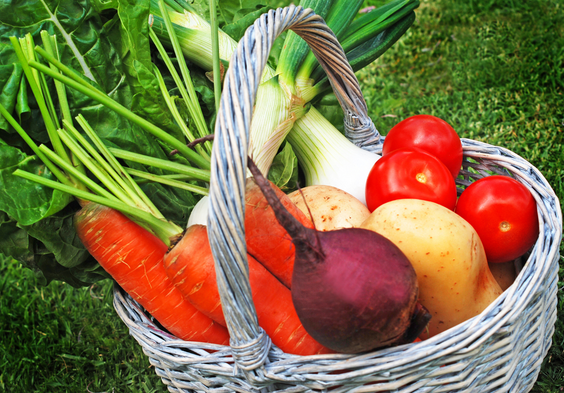
This may be in order to:
- Promote a local industry or product
- Take advantage of lower costs involved in buying local
- Cater to tourists who may be seeking a taste of the local region.
When deciding on menu items to be included on the menu, menu suggestions must be balanced in terms of cost and variety and to reflect the type of enterprise and regional location.
Commercial venues must operate at a certain profit level to remain viable, and control of food cost is a critical aspect of this.

Elements of a Dish
Elements are all the components that make a dish or menu item complete.
Start with the main part of the dish:
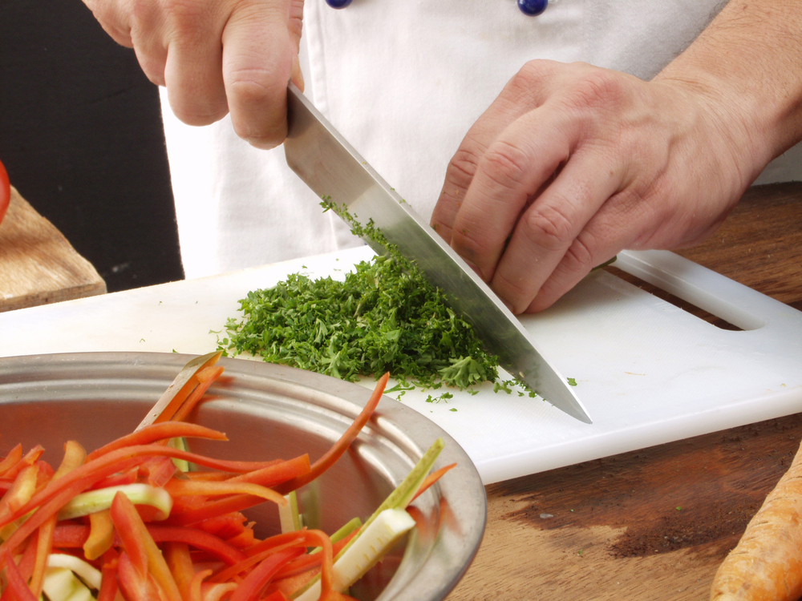
- Piece of meat, poultry or fish; it may be in a single piece that has been grilled or as a curry/casserole
- Vegetables: this may be broken down to each vegetable type and the amount of each piece
- Sauce and the amount of that sauce; served on side or over meat or vegetables
- Garnish: determined by colour. size and how it is to be presented
- Salad served with the dish: on same plate or at the side
- Condiment: similar to sauce but not necessarily made in house; mustards and chutneys
- Farinaceous component to a dish; potatoes, rice, lentils.

Considering cost and variety
All dishes should be costed to ensure they return the required margin of profit, and standard recipes used to guarantee consistency of this return.
In some instances, establishments may make a conscious decision to offer a dish at reduced profit margin in order to maintain continuity, cater for guest expectations, meet competition or create a unique selling point (that is, an aspect of their business that no other venue has).
This can only be done in an on-going way when other dishes (or other revenue streams – drinks, accommodation, and gaming) are able to return a higher profit margin to compensate.

How much to charge?
There is no doubt that, given all the dining alternatives available to people, there is a price point above which many people will not go when eating out.
There is less elasticity in this price for lunch meals: that is, there is less room to move in terms of setting prices at lunch time – people traditionally have cheaper alternatives at lunch time, and there are more places open and a greater range of alternatives.
This means that management must actively monitor things such as ‘average selling price per cover’, and the prices being charged by their immediate competition in order to determine what a viable selling price is being charged.
It is a commonly held theory when pricing meals, that food cost should equal 30% – 33% of the selling price. This will naturally vary depending on country industry standards.

Specials and Themes
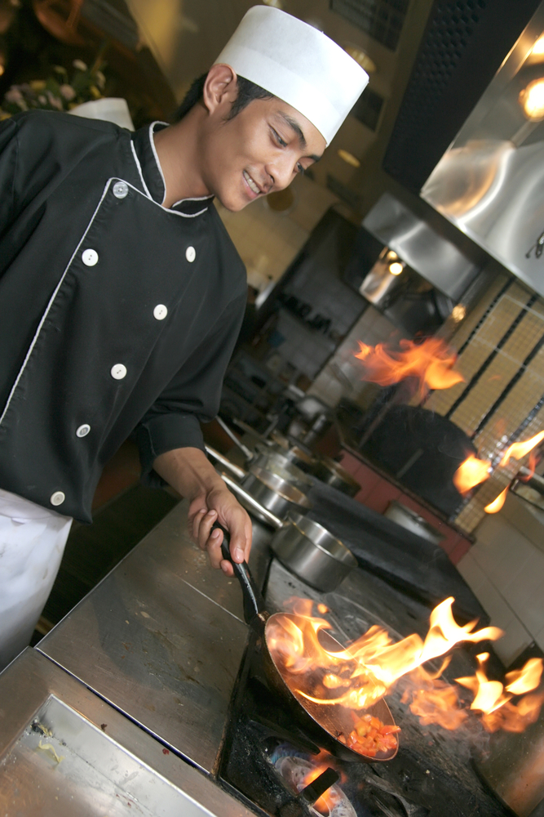
One method of maintaining the desired menu items on the standard menu, and yet still providing alternatives and variations is the use of Daily Specials.
These Chef’s Specials or House Specials enable the chef to:
- Capitalise on cheaper food items and produce menu items that will return a higher level of profit than normal
- Create interest and ‘something different’ in the menu
- Cater for immediate short-term demand for a certain dish
- Use up left-over food or items that are approaching their use-by date by developing a dish that will include those ingredients.
Another option that appears to be growing in popularity is to offer regular theme meals (lunch or dinner, or both) where a specific topic is targeted on a one-off basis.
This may mean that the establishment runs a heavily advertised dining extravaganza such as:
- A seafood night | - A Hawaiian day | - Curries of the world
- Schnitzel day | - German day | - Mexican fiesta
Suggestions for these special events can be sought from customers with a view to engaging them in the whole process and optimising their participation and attendance.
Staff can be dressed in an accompanying costume, suitable music played and appropriate beverages supplied to further support the initiative.
Type of enterprise
To some extent the type of enterprise can dictate the food that will be offered.
For example, take-away premises will feature meals and items that can be prepared quickly and effectively wrapped and packaged for taking away.
- A German Beer house is locked into German fare.
A pizza house is centred on pizza with diversity being available through choice of toppings and an expansion, perhaps, into pasta.
By the same token, what might you expect at a Steak house?
Planning activities related to cost and variety
Planning is an important aspect of menu development and one that must be fully appreciated.
An establishment cannot decide today to change its menu tomorrow. It might be able to introduce one new dish tomorrow, but that’s about it especially if it wants to do it successfully and profitability.

Issues involved in the planning of menus and decisions about what will be included on the menu include:
- Sourcing of the necessary ingredients
- Ensuring the ingredients are cost-effective
- Developing suitable recipes and taste testing of recipes to ensure that patrons approve of them and will buy them: remember, it’s not what you (or the owner) likes that counts – it’s what the customer likes and is prepared to pay for!
- Identification of suitable serve sizes – we don’t want to offer too much because bigger serves means higher prices but on the other hand we don’t want to be accused of providing serves that are too small
- Considering presentation of the dishes – including making decisions about garnishes, plates, position of items on the plate, colours, textures of the different foods that will be used
- Obtaining any new equipment that may be needed to prepare/cook the dish – and getting staff up-to-speed with using that equipment
- Training staff –to ensure that kitchen staff can produce the new items and that service staff know all about them and can effectively recommend and sell them
- Deciding on the type of menu to be used – the development of a new menu sometimes provides the opportunity to alter the style, format, nature etc. of the menu.
Where a paper-based menu is going to be used, it also has to be written (that is, description of dishes have to be provided in-line with establishment requirements), checked and an appropriate number of them need to be printed.

1.4 Prepare menu costing

Cost control

The overall objective of any commercial establishment should be to make money which is established by using the following formula:
- Sales - cost of ingredients = gross profit
- Sales - all costs (wages, cost of ingredients, overheads) = net profit.
Example: XYZ establishment has taken $10,000.00 for one week’s trading, its cost of ingredients was $3,500.00 and overall expenses were $8,500.00.
If the above formula was applied to this restaurant, it would look something like this:
- $10,000.00 (sales) - $3,500.00 (cost of ingredients) = $6,500.00 (gross profit)
- $10,000.00 (sales) - $8,500.00 (overall expenses) = $1,500.00 (net profit).
When expressed as a percentage, it would look like this:
- 100% (sales) - 35% (cost of ingredients) = 65% (gross profit)
- 100% (sales) - 85% (overall expenses) = 15% (net profit).

Food Cost Factors
Food cost factor is the cost of the food ingredients compared to the selling price of the menu item.
It does not include the cost of wages for the making of the menu items.
The issue with buying food for a menu is that it usually has a limited shelf life.
Coupled with the fact that it can also be expensive, this places significant emphasis on the purchaser to make sure he/she orders exactly what is needed, as well as scheduling where and when it is required.
Factors which will affect purchasing include:
- Regular menu changes
- Slow moving dishes
- Diner’s fluctuating choices; how many customers will come to the establishment today?
- Staff not adhering to standard recipes
- Food wastage and theft.

Standard Recipes
A standard recipe is a precise record of ingredients, method, serving instructions and cost of any food item on a menu.
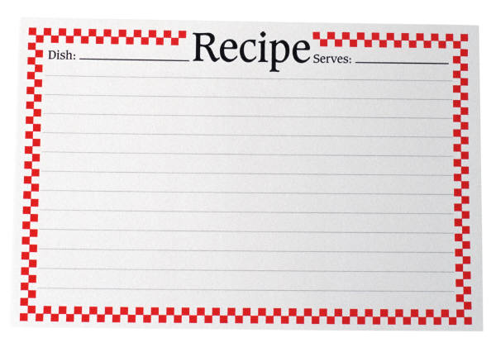
A standard recipe needs to include:
- Summary of ingredients
- Required quantities or each item
- Specific preparation guidelines
- Garnish and service details
- Portion sizes
- Accurate costs
- % wastage
- Date.
Why do we use them?
- Standardise production of recipes -regardless of who makes them
- Consistent quality – always taste the same
- Consistent presentation – always look the same
- Consistent portion size - always the same quantity
- Easy to calculate cost of dish – and re-establish cost of dish
- Customer satisfaction.
To calculate cost of purchase amount:
FORMULA: Cost per Unit ÷ Unit x Purchase Amount = Cost of purchase amount
EXAMPLE: Apples $2.99 ÷ 1000 g x 255 g = $0.76
Balsamic Vinegar $2.38 ÷ 375 ml x 125 ml = $0.79
Basil $2.00 ÷ 1 each x .5 = $1.00
Student Activity
Using the form on the following pages students are to price the given recipes in local currencies and then apply those costs to the standard recipe sheets and determine how much each recipes costs to produce.

Portion Control
Portion control is to control the quantity of food served to each customer.
WHY?
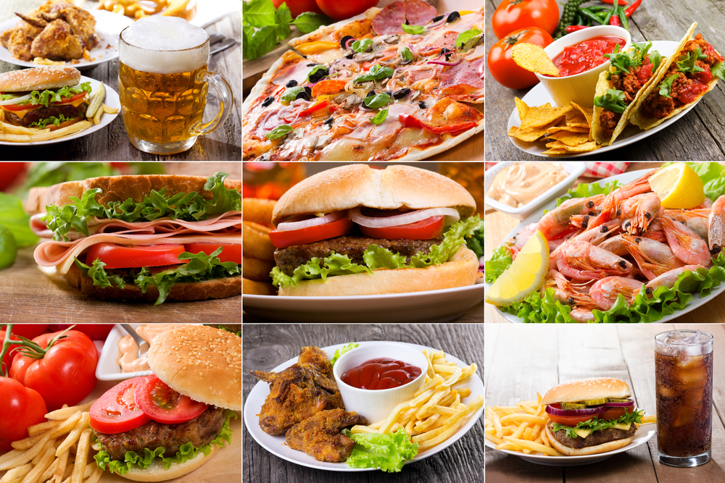
- To know how much food to order
- To know what yield is obtained from each food item
- Helps to calculate the cost of each dish on a menu therefore its selling price
- To ensure each customer receives a meal that is uniform in quantity and standard.
Portion sizes can be determined by:
- Number of courses to be served
- Size and design of crockery
- Type of customer
- Menu pricing structure.
Portion sizes can be controlled by:
- Buying food of specific portion size
- Training staff on how to control portions and why it is important
- Using appropriate utensils, equipment and measures to serve food
- Supervising staff during service.

Portion sizes
Portion size is determined by the head chef in consultation with management.
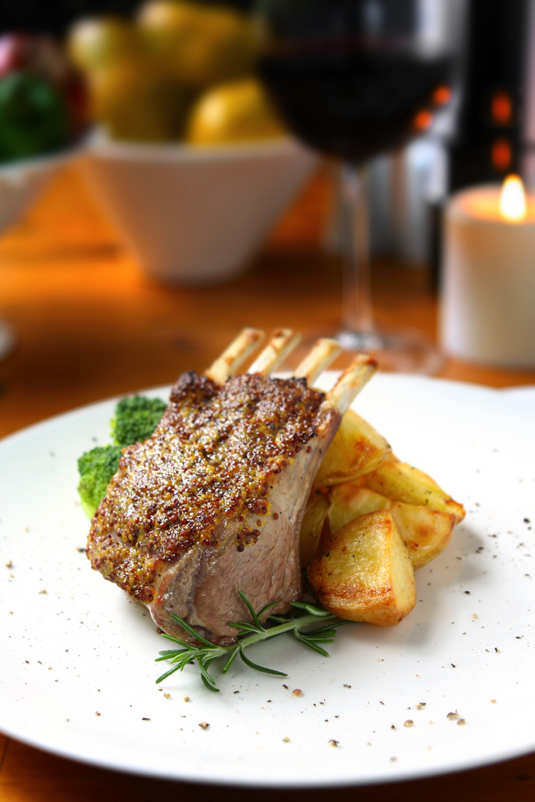
Meat, Fish and Poultry
- 150 g in pastry or similar
- 180 g pure meat i.e. Fillet steak
- 200 g Sirloin, Rump
- 250 – 300 g T-Bone, Whole Trout, Flounder.
Vegetables
2 x 50 g each; Example: Broccoli & Carrot (used to be meat, 2 vegetables plus a farinaceous item)
Farinaceous (potato, pasta, rice, etc.)
100 g for a main meal, 30 – 75 g for an entrée
(Today menus give a vegetable or farinaceous of between 50 - 100 g each)

Shellfish
60 – 90 g per entree portion depending on how rich the overall dish is and what else is served with it.
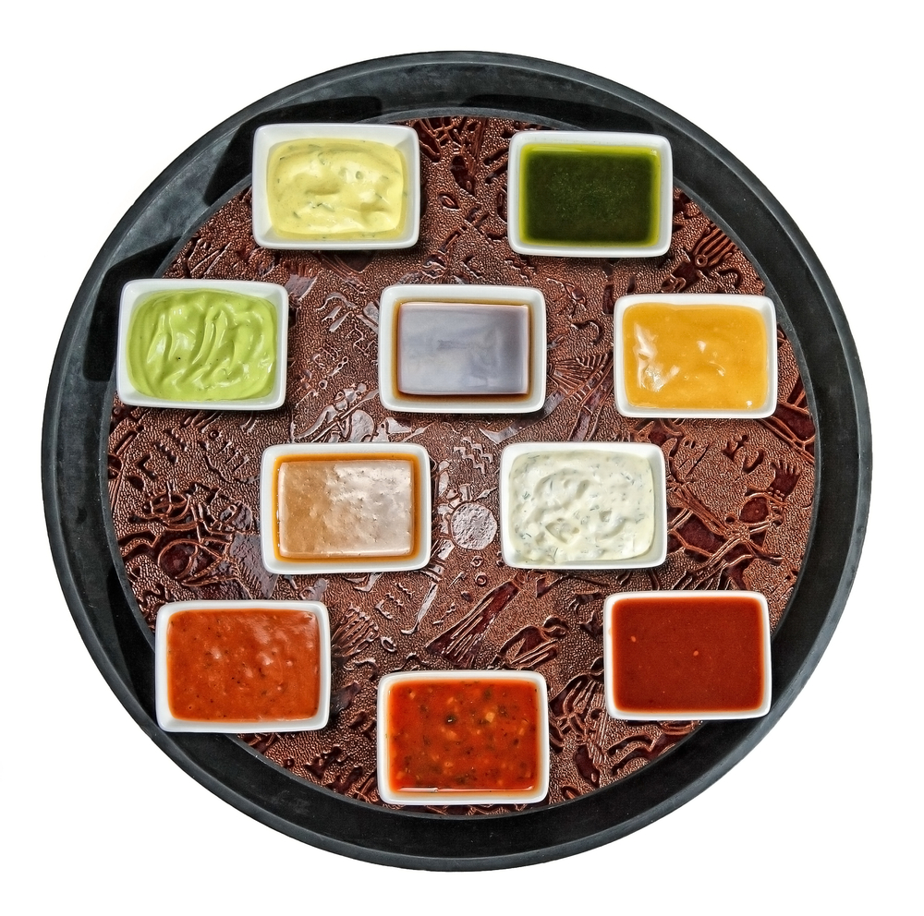
Soup
200 – 250 ml per entree portion
Sauce
20 - 50 ml per portion depends on the richness of the sauce.
Cakes
20 cm 8 or 10 portions
25 cm 12 portions
30 cm 16 portions
(All of the above depend on the thickness and richness of the cake)
To obtain good portion control the chef/cook needs to know the yields for various raw and processed products they work with, therefore it is important to make a habit of regularly counting, measuring and weighing food products in the Kitchen when working with them.
For example:
How many dry biscuits are in a packet?
Slices of bread in a normal sliced loaf
How many apricots halves in a tin of 445g weight?

Portion control exercises
I need 55 portions of fish fillets weighing 120 g each. How much fish do I need to purchase?

How much smoked salmon do I need to buy for a function of 550 people, giving 3 slices per person when each slice weighs 45 g?

I bought 2 turned potatoes per person for a function of 45 people. What is the portion size, and how much did I need to buy?

I bought a 2.5 kg tub of semi-dried tomatoes. Giving 20 g per person, how many portions are there?

A 3.250 kg cooked, boned leg of lamb will yield how many portions of 175 g?

I need to cook 85 portions of rice for a buffet. How much raw weight of rice do I need to cook?

How many black forest cakes (25 cm) do I need to buy for a function of 120 people?

How many 180 gm sirloin steaks will I yield from a trimmed 3.42 Kg sirloin?

Rounding off when Calculating Figures
Rounding up or down is used when an answer gives more than the required decimal places.
To obtain the correct figure we must remove the excess figures:

For example:
- $1.678 = $1.68 All currency has 2 decimal places
- 5.684463 kg = 5.684 kg All weight measures have 3 decimal places
- 75.675% = 76% (For our entire exercises %’s have no decimal point).
Depending on the first figure being removed, we round up or down. If the figure is 5 or higher we round up, if 4 or lower no change.
For example:
- $1.678 we remove the 8 and round up to $1.68 because the figure is 5 or higher
- 5.684463 kg we remove 463 and remain the same 5.684 kg because the first figure is 4 or lower.

Working out Percentages
A percentage is an expression of a proportion or part, in relation to the whole or total.
For example:
- 25 out of 100 = 25 % OR 50 out of 200 = 25 %
- Using a calculator 42 out of 68 = 61.76%
- 42 is 62 % of 68
- Enter 42 into calculator then ÷ then 76 follow by % key: 61.764705; round up to 62.

Exercise in working out percentages (%)
36 out of 50
48 out of 50
29 out of 74
83 out of 110
65 out of 93
26.5 out of 89.5
43.24 out of 69.6

Commodity purchase requirements
Defining how much you need to produce a recipe.
When developing a recipe there is a requirement to know how much you need to purchase in order to have enough at the end of the cooking process.
- Weight when purchased
- Weight when peeled and trimmed to meet requirements of recipe
- Weight at the end of the cooking process.
On the wastage and price list page it will give an example of various products and the weight they will be when peeled, cored or have excess flesh removed.
All students need to do tests to see how much is left when product is prepared for production.
Student Activity
On the blank pages supplied the student should start their own database of ingredient cost and wastage %.
When a product has been prepared the product should be weighed to see how much is left.
If 1kilo of carrot is required then 8% more needs to be purchased to obtain 1 kilo of carrot after it has been peeled.

Calculating Purchase Weight
Purchase weight is the amount that will be required to be purchased to meet the required weight in the recipe.
On the following page there is a list of ingredients with weight and purchases cost.
Also there is a column that shows wastage.
This wastage is the part of the product that would not normally be used.
Example: Carrots
When 1 kilo of carrots are purchased, they are then peeled, top removed and normally the tip as well because this may be damaged or too thin to be bothered with.
8% of the kilo has been determined to be lost.
If the carrot is then cut to specific size then more will be lost due to irregular shapes.
This also has to be allowed in calculations.
If julienne of carrot is required then from that 920g that is left the carrot will have to be trimmed and cut to size.
Any off cuts that are to be used in other dishes like stocks and soups will then be set aside.
Weighing the remaining usable carrot may leave you with only 750g out of 1 kilo.
If I was to require 1 kilo of julienne carrots I would have to purchase 1.34 kilo of carrot.
Using Calculator enter: 1 next ÷ follow by 75 then hit % key and 1.3333 should be showing.
Formula
Portion Weight ÷ Useable % X 100 = Purchase Weight
For example:
1 ÷ 75 touch % key then it shows 1.3333 round up to 1.34
If the cost of purchasing the carrot was $2.99 per kilo and I needed 1.34kilo 5to obtain 1 kilo of julienne of carrot then the cost of the kilo of julienne of carrot will be $4.00.
$2.99 x 1.34 kilo = $4.0066; round down to $4.00 per kilo of julienne of carrot.

Wastage and Price List for Standard Recipes
Listed below are some figures that are for exercise purposes only. Students are encouraged to set up their own database that shows the following information.
Ingredient | Unit | Cost |  | Wastage
Anchovy’s, canned | 1000 | $10.00 |  | 0.00 %
Apples Red | 1000 | $2.99 |  | 22.00%
Bacon | 1000 | $7.20 |  | 0.00%
Bacon Bones | 1000 | $2.99 |  | 0.00%
Balsamic Vinegar | 375 | $2.38 |  | 0.00%
Banana | 1 | $0.50 |  | 21.00%
Basil | 190 | $2.00 |  | 0.00%
Bay leaves | 3 | $0.05 |  | 0.00%
Bouquet Garni | 10 | $0.50 |  | 0.00%
Bread | 10 | $16.00 |  | 8.00%
Breadcrumbs | 1000 | $5.30 |  | 0.00%
Butter | 250 | $0.99 |  | 0.00%
Cabbage | 100 | $1.90 |  | 22.00%
Carrots | 1000 | $1.49 |  | 8.00%
Celery | 1000 | $3.99 |  | 26.00%
Cheese, grated | 1000 | $4.90 |  | 0.00%
Cherry Tomatoes | 250 | $1.30 |  | 0.00%
Chervil | 190 | $2.50 |  | 0.00%
Chicken Bones | 1000 | $2.99 |  | 0.00%
Chicken Breast | 1000 | $7.99 |  | 0.00%
Chicken Liver | 1000 | $3.89 |  | 5.00%
Chicken Stock | 1000 | $1.54 |  | 0.00%
Chicken (no.10) | 1000 | $4.99 |  | 31.00%
Chives | 4 | $2.00 |  | 0.00%
Chocolate | 1000 | $2.55 |  | 0.00%
Cointreau | 750 | $30.00 |  | 0.00%
Cos Lettuce | 10 | $12.90 |  | 12.00%
Cream | 300 | $1.20 |  | 0.00%
Cucumber | 1000 | $0.39 |  | 24.00%
Dry Mustard | 500 | $2.56 |  | 0.00%
Egg white | 12 | $2.40 |  | 0.00%
Egg yolk | 12 | $2.40 |  | 0.00%
Flour | 1000 | $1.10 |  | 0.00%
Frying Oil | 1000 | $32.85 |  | 0.00%
Garlic | 1000 | $11.99 |  | 5.00%
Green Prawns | 1000 | $18.00 |  | 12.00%
Haricot Beans | 1000 | $2.80 |  | 0.00%
Honeydew Melon | 1 | $1.80 |  | 22.00%
Icing Sugar | 1000 | $1.80 |  | 0.00%
Juniper Berries | 4 | $0.05 |  | 0.00%
King Island Cream | 1000 | $8.00 |  | 0.00%
Kiwi fruit | 1 | $0.40 |  | 5.00%
Leek | 1000 | $4.98 |  | 57.00%
Lemongrass | 4 | $2.00 |  | 0.00%
Lemons | 10 | $2.90 |  | 0.00%
Lime | 10 |  | $3.50 | 0.00%
Mescalin Lettuce | 1000 |  | $2.30 | 0.00%
Milk | 1000 |  | $1.60 | 0.00%
Mint | 100 |  | $2.00 | 0.00%
Mud cake | 1 |  | $24.00 | 0.00%
Mushroom | 1000 |  | $5.99 | 25.00%
Mustard | 250 |  | $2.50 | 0.00%
Olive Oil | 1000 |  | $5.18 | 0.00%
Onion | 1000 |  | $0.99 | 5.00%
Oranges | 1 |  | $0.21 | 6.00%
Oregano | 190 |  | $2.00 | 0.00%
Parmesan Cheese | 1000 |  | $12.99 | 0.00%
Parsley | 120 |  | $2.00 | 0.00%
Peas | 1000 |  | $1.66 | 0.00%
Peppercorns | 3 |  | $0.05 | 0.00%
Pineapple | 1 |  | $1.80 | 20.00%
Pine nuts | 1000 |  | $15.00 | 0.00%
Potato | 1000 |  | $0.59 | 1.40%
Prunes | 1000 |  | $5.23 | 0.00%
Pumpkin Butternut | 1000 |  | $0.99 | 25.00%
Rack of Lamb | 10 |  | $24.00 | 0.00%
Raspberry | 1000 |  | $9.85 | 0.00%
Red Capsicum | 1000 |  | $2.48 | 10.00%
Rosemary | 120 |  | $2.00 | 0.00%
Salmon | 1000 |  | $20.00 | 15.00%
Salt | 1000 |  | $7.90 | 0.00%
Salt and Pepper | 1000 |  | $9.00 | 0.00%
Seasoning | 1000 |  | $9.00 | 0.00%
Shallot | 1000 |  | $7.00 | 5.00%
Sherry Vinegar | 500 |  | $4.50 | 0.00%
Sirloin Steak | 1000 |  | $8.65 | 27.00%
Snow peas | 1000 |  | $12.00 | 0.00%
Spaghetti | 500 |  | $1.56 | 0.00%
Strawberries | 250 |  | $2.99 | 3.00%
Sugar | 1000 |  | $1.03 | 0.00%
Sugar Snap peas | 1000 |  | $8.99 | 0.00%
Tarragon | 120 |  | $2.00 | 0.00%
Thyme | 120 |  | $2.00 | 0.00%
Thyme Lemon | 13 |  | $2.00 | 0.00%
Tomato | 1000 |  | $2.49 | 6.00%
Tomato Juice | 250 |  | $1.20 | 0.00%
Tomato Paste | 50 |  | $0.90 | 0.00%
Tomato Sun-Dried | 1000 |  | $15.00 | 0.00%
Tomato Tinned | 400 |  | $2.30 | 0.00%
Vanilla Essence | 250 |  | $2.45 | 0.00%
Vegetable oil | 1000 |  | $2.99 | 0.00%
Vinegar | 1000 |  | $2.05 | 0.00%
Zucchini | 1000 |  | $2.99 | 25.00%

Students can use these sheets to gather the prices in their marketplace.
Wastage is how much weight is lost when preparing product for use in a % (percentage).
Ingredient | Unit | Cost | Wastage
Anchovy’s
Apples Red
Bacon
Bacon Bones
Balsamic Vinegar
Banana
Basil
Bay leaves
Bouquet Garni
Bread
Breadcrumbs
Butter
Cabbage
Carrots
Celery
Cheese, grated
Cherry Tomatoes
Chervil
Chicken Bones
Chicken Breast
Chicken Liver
Chicken Stock
Chicken (no.10)
Chives
Chocolate
Cointreau
Cos Lettuce
Cream
Cucumber
Dry Mustard
Egg white
Egg yolk
Flour
Frying Oil
Garlic
Green Prawns
Haricot Beans
Honeydew Melon
Icing Sugar
Juniper Berries
King Island Cream
Kiwi fruit
Leek
Lemongrass
Lemons
Lime
Mescalin Lettuce
Milk
Mint
Mud cake
Mushroom
Mustard
Olive Oil
Onion
Oranges
Oregano
Parmesan Cheese
Parsley
Peas
Peppercorns
Pineapple
Pine nuts
Potato
Prunes
Pumpkin Butternut
Rack of Lamb
Raspberry
Red Capsicum
Rosemary
Salmon
Salt
Salt and Pepper
Seasoning
Shallot
Sherry Vinegar
Sirloin Steak
Snow peas
Spaghetti
Strawberries
Sugar
Sugar Snap peas
Tarragon
Thyme
Thyme Lemon
Tomato
Tomato Juice
Tomato Paste
Tomato Sun-Dried
Tomato Tinned
Vanilla Essence
Vegetable oil
Vinegar
Zucchini

Standard Recipe Costing 1
This is an example of how to fill in a Standard recipe sheet:
Recipe | Roast Stuffed Chicken with roast vegetables
Number of Portions: 10 |  |  |  | Portion size: .5 chicken per person
Ingredient | Amount | Unit | Waste  % | Useable | Purchase  Weight | Cost  per  Unit |  | Cost of  purchase  Amount
Chicken (no 10) | 5 ea | ea | 0% | 100% | 5 | $ 4.99 |  | $ 24.95
Stuffing
Egg White | 1 ea | 12 | 0 |  | 1 | $2.40 |  | $0.20
Onion | 100g | 1000 | 5 | 95 | 105 | $0.99 |  | $0.10
Rosemary | .25 bch | ea |  |  | 25 | $2.00 |  | $0.50
Thyme | .25 bch | ea |  |  | 25 | $2.00 |  | $0.50
Oregano | .25 bch | ea |  |  | 25 | $2.00 |  | $0.50
Tarragon | .25 bch | ea |  |  | 25 | $2.00 |  | $0.50
Prunes | 100 g | 1000 |  |  | 100 | $5.23 |  | $0.52
Pine nuts | 50 g | 1000 |  |  | 50 | $15.00 |  | $0.75
Bread crumbs | 200 g | 1000 |  |  | 200 | $5.30 |  | $1.06
Vegetable Oil | 20 g | 1000 |  |  | 20 | $2.99 |  | $0.06
Salt | 10 g | 1000 |  |  | 10 | $7.90 |  | $0.08
Pepper | 5 g | 1000 |  |  | 5 | $9.00 |  | $0.05
Roast Vegetables
Potatoes | 1000 g | 1000 | 1.4 | 98.6 | 1014 | $0.59 |  | $0.60
Pumpkin | 500 g | 1000 | 25 | 75 | 667 | $0.99 |  | $0.66
Zucchini | 500g | 1000 | 25 | 75 | 667 | $2.99 |  | $1.99
Chicken Stock | 500ml | 1000 |  |  | 500 | $1.54 |  | $0.77
Parsley | .25bch | ea |  |  |  | $2.00 |  | $0.50
Total Cost |  |  |  |  |  |  |  | $34.02
Cost per individual Portion |  |  |  |  |  |  |  | $3.40
Selling Price @ 33% f.c. |  |  |  |  |  |  |  | $10.30
Method of production, cooking temperatures and plating procedures
Tested and Approved by: |  |  |  |  |  |  | Date

Exercise - Standard Recipe Costing 2
Recipe |  | Garlic Prawn
Number of Portions |  | 10 |  |  | Portion size: 100g
Ingredient | Amount |  | Unit | Waste  % | Useable | Purchase  Amount | Cost  per  Unit |  | Cost of  purchase  Amount
Prawn Cutlet | 900 |  | ea
Butter | 100 |  | g
Garlic | 80 |  | g
Parsley | .25 |  | bch
lemons | 3 |  | ea
Total Cost
Cost per individual Portion
Selling Price @ 28% f.c.
Method of production, cooking temperatures and plating procedures
Tested and Approved by: |  |  |  |  |  |  |  | Date

Exercise - Standard Recipe Costing 3
Recipe | Sirloin Steak with garlic butter and French fries
Number of Portions |  |  |  | Portion size:
Ingredient | Amount | Unit | Waste  % | Useable | Purchase  Amount | Cost  per  Unit |  | Cost of  purchase  Amount
Sirloin Steak | 2000 | g
Vegetable oil | 60 | ml
Garlic Butter
Salt | 20 | g
Pepper | 10 | g
Butter | 300 | g
Garlic | 10 | g
Parsley | .25 | bch
Lemon | 1 | ea
French Fries
Potatoes | 1000 | g
Frying Oil | 500 | g
Side Salad
Salad leaves | 250 | g
Tomatoes | 5 | ea
Cucumber | .5 | ea
Dressing
Olive oil | 200 | ml
Vinegar | 100 | ml
Salt | 5 | g
Pepper | 3 | g
Total Cost
Cost per individual Portion
Selling Price @ 28% f.c.
Method of production, cooking temperatures and plating procedures
Tested and Approved by: |  |  |  |  |  |  | Date
Standard Recipe Costing
Recipe
Number of Portions |  |  |  | Portion size:
Ingredient | Amount | Unit | Waste  % | Useable | Purchase  Amount | Cost  per  Unit |  | Cost of  purchase  Amount
Total Cost
Cost per individual Portion
Selling Price @ 28% f.c.
Method of production, cooking temperatures and plating procedures
Tested and Approved by: |  |  |  |  |  |  | Date

The price of the olives
Item | Qty | Unit: Kg | Value | Value per unit
Olives | 2.25 | 1 | $5.48 | $2.43
This makes the price of olives $2.43 per kilo.
Alternatively:
Item | Qty | Unit: grams | Value | Value per unit
Olives | 2.25 | 1000 | $5.48 | $0.0024357
This makes the price of olives .25 of one cent per gram.
Why worry about this?
How do you work out the cost of one olive?
To establish the price of olives simple tests need to be conducted periodically.
- Establish an average
- Take 10 olives and weigh them
- If this weighs 45 gm then an average weight for the olives is 4.5 grams each
- 4.5 gram multiplied by cost of per gram $0.0024357 equals 0.0109606 cents for each olive.
If the dish calls for 8 olives per salad then the cost will be $0.0876848 round up to 9 cents per salad.
Each time the salad is made you will not necessarily count the olives but at the end of the trading period and there has been 2,400 salads sold then the accountants will want to know where the 19,000 olives have been used.
Establish a data base and keep it up to date.
Student Activity
The following pages are exercises for the students. These are exercises that will allow them to obtain the skills required to cost a menu and define cost of food compared with total sales.

Food Cost and Food Cost % for a Period


Formula
Opening Stock + Purchases = Total Stock
Total Stock - Closing Stock = Food Cost
Food Cost ÷ Sales for the Period x 100 = Food Cost %

Example
Opening Stock $22,642.23  +  Purchases $20,238.01  =  Total Stock $ 42880.24  -  Closing Stock $19,957.64  =  Food Costs $ 22,922.60  ÷  Sales $71,967.45  =  .3185134 x 100  =  Food Cost % 31.85% | Opening Stock $ 22,642.23  +  Purchases $ 20,238.01  =  Total Stock $ 42880.24  -  Closing Stock $ 19,957.64  =  Food Costs $ 22,922.60  ÷  Sales $ 71,967.45  Use % key  31.85134  =  Food Cost % 31.85%

Exercises to calculate food costs and food cost %

Exercise 1
Opening Stock $22,642.23 $19,957.64 $18,389.27 $17,599.83
Purchases $20,238.01 $17,345.23 $20,486.19 $22,565.94
Closing Stock $19,957.64 $18,389.27 $17,599.83 $18,982.93
Food Costs = __________ __________ __________ __________
Sales = $71,967.45 $69,364.56 $75,978.23 $71,013.08
Food Cost % = __________ __________ __________ __________

Exercise 2
Opening Stock $24,161.23 $20,399.79 $18,891.55 $17,798.36
Purchases $16,986.64 $19,784.28 $20,124.89 $20,793.99
Closing Stock $20,399.79 $18,891.55 $17,798.36 $19,287.84
Food Costs = __________ __________ __________ __________
Sales = $74,508.74 $71,281.34 $68,897.95 $69,563.64
Food Cost % = __________ __________ __________ __________

Exercise 3
Opening Stock $23,226.42 $20,238.01 $17,839.59 $18,939.82
Purchases $19,345.23 $18,273.89 $22,945.65 $20,287.84
Closing Stock $20,238.01 $17,839.59 $18,939.82 $19,737.86
Food Costs = __________ __________ __________ __________
Sales = $69,563.64 $70,012.84 $71,080.13 $ 69,094.48
Food Cost % = __________ __________ __________ __________

Exercises to calculate restaurant food cost

Exercise 1
At the Shining Sun Restaurant, stock take is done by the chef every three months to find the actual food cost %. The food cost % the kitchen aims to achieve is 33%.
Below is a table of information which the chef works out every month as a guide to find the food cost in relation to the actual sales made.
Some of the information is missing and you need to fill in the blank spaces.
Month | Food Cost $ | Sales $ | Food Cost %
January | 15071.84 | 45672.25
February | 13438.86 |  | 33%
March |  | 44573.58 | 33%
Total
Now your task is to complete the three monthly stock take and find the actual food cost % using the information provided.
Opening Stock: $10694.28
Closing Stock: $8725.49
Purchases: See invoices
Opening Stock
Purchases
Total Stock
Closing Stock
Food Cost $
Actual Food Cost %

Mac’s Meats Inc.
Invoice No: 96548521 |  | For the period beginning January 1
 |  | Ending: March 31st
January | $ 5826.70
February | $ 6273.35
March | $ 3363.02
Total
Fruit & Veg
Invoice No: 96548521 |  | For the period beginning January 1
 |  | Ending: March 31st
January | $ 4682.86
February | $ 3245.26
March | $ 4145.08
Total
Fine Foods
Invoice No: 456820 |  | For the period beginning January 1
 |  | Ending: March 31st
January | $ 3125.60
February | $ 3268.30
March | $ 2587.96
Total
Pluckas Poultry
Invoice No: 96548521 |  | For the period beginning January 1
 |  | Ending: March 31st
January | $ 3826.15
February | $ 2268.05
March | $ 2577.95
Total

Exercise 2
At the Main Road Restaurant, stock take is done by the chef every three months to find the actual food cost %. The food cost % the kitchen aims to achieve is 32.5%.
Below is a table of information which the chef works out every month as a guide to find the food cost in relation to the actual sales made.
Some of the information is missing and you need to fill in the blank spaces.
Month | Food Cost $ | Sales $ | Food Cost %
January |  | 46311.02 | 32.5%
February | 11601.12 | 35695.74
March | 12813.80 |  | 32.5%
Total
Now your task is to complete the three monthly stock take and find the actual food cost % using the information provided.
Opening Stock: $9542.43
Closing Stock: $8122.13
Purchases: See invoices
Opening Stock
Purchases
Total Stock
Closing Stock
Food Cost $
Actual Food Cost %

Mac’s Meats Inc.
Invoice No: 96548521 |  | For the period beginning January 1
 |  | Ending: March 31st
January | $ 4321.68
February | $ 3382.70
March | $ 3988.47
Total
Fruit & Veg
Invoice No: 96548521 |  | For the period beginning January 1
 |  | Ending: March 31st
January | $ 3548.20
February | $ 3672.80
March | $ 3444.22
Total
Fine Foods
Invoice No: 96548521 |  | For the period beginning January 1
 |  | Ending: March 31st
January | $ 4732.15
February | $ 5286.20
March | $ 2565.85
Total
Pluckas Poultry
Invoice No: 96548521 |  | For the period beginning January 1
 |  | Ending: March 31st
January | $ 2324.02
February | $ 1706.50
March | $ 1448.00
Total

Exercise 3
At the Very Good Restaurant, stock take is done by the chef every three months to find the actual food cost %. The food cost % the kitchen aims to achieve is 34%.
Below is a table of information which the chef works out every month as a guide to find the food cost in relation to the actual sales made.
Some of the information is missing and you need to fill in the blank spaces.
Month | Food Cost $ | Sales $ | Food Cost %
January | 28139.19 |  | 34
February |  | 75438.86 | 34
March | 25590.86 | 75267.22
Total
Now your task is to complete the three monthly stock take and find the actual food cost % using the information provided.
Opening Stock: 22670.33
Closing Stock: 25234.42
Purchases: See invoices
Opening Stock
Purchases
Total Stock
Closing Stock
Food Cost $
Actual Food Cost %

Mac’s Meats Inc.
Invoice No: 965423585 |  | For the period beginning January 1
 |  | Ending: March 31st
January | $ 9267.82
February | $ 10136.40
March | $ 6680.81
Total
Fruit & Veg
Invoice No: 96548521 |  | For the period beginning January 1
 |  | Ending: March 31st
January | $ 7263.85
February | $ 6428.72
March | $ 7132.23
Total
Fine Foods
Invoice No: 96548521 |  | For the period beginning January 1
 |  | Ending: March 31st
January | $ 6724.89
February | $ 9348.20
March | $ 4275.11
Total
Pluckas Poultry
Invoice No: 96548521 |  | For the period beginning January 1
 |  | Ending: March 31st
January | $ 3678.27
February | $ 2468.80
March | $ 2935.00
Total

1.5 Produce finished/final menu

Introduction
Professional cooks need to develop a menus for an eating establishment based on modern trends.
The Trainer will direct the students on which type of menu that will be required.
When developing the menu needs to offer:
- Variety in the choice selection.
Look at the colour and texture of the food in the dishes:
- Everything deep fried is very limited
- All seafood, no matter how good is limiting.
Colour needs to be appealing and overcooked vegetables will be dull and disappointing.
Modern menu will have a wide variety of selection to appeal to the modern palate.
The menu needs to match the taste of the cuisine with a good mix of contemporary foods from other cuisines.
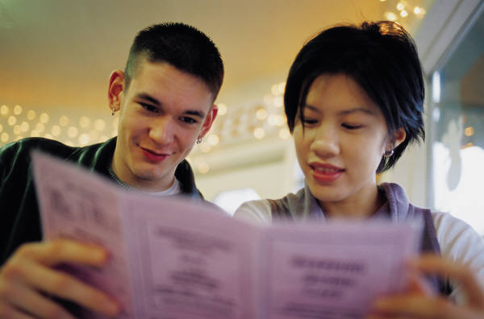
The average menu will have 3 sections:
- Entrée or starter
- Main
- Desserts.
Some other menus may have other offerings in the:
- ‘Pasta’ section
- ‘Salad’ section
- ‘Side’ selection.
The number of dishes will vary depending on size of kitchen and how often they change the menu:
- Menus may be large
- Menu may be small.
Size and number of offerings on the menu is decided by management in consultation with the head chef.
Student Activity
What does a Brazilian Churrascaria serve?
Students to research.

Work Projects
It is a requirement of this Unit you complete Work Projects as advised by your Trainer.
You must submit documentation, suitable evidence or other relevant proof of completion of the project to your Trainer by the agreed date.
Suitable requirements for this unit may be a report that answers the following criteria:
1.1 Define the requirements of the enterprise
- Cooks will work at a variety of venues in their working life
- Different venues may meet the following criteria
- A la carte
- Function venue
- Café
- Hospital.
1.2. Writing of the menu
- There is to be a standard menu used in each of four (4) outlets
- Fine dining
- Coffee shop
- Kiosk poolside outlet
- High tea or afternoon tea service
- Highlight any potentially allegoric ingredients
- Highlight meals suitable for vegetarian (V)
- When highlighting use following symbols
- Vegetarian (V)
- Gluten (G)
- Peanut (P).
1.3. Costing of the menu
- Chose one menu and apply a costing to each of the menu items
- Justify prices with local market costs.

Summary

Plan and write menus
Establish the enterprise and/or clients requirements for menu/s
What are the requirements of the enterprise?
What are the requirements of the client?
When people go into business they will decide on a specific style of food that will be produced.
Larger establishments may have multiple outlets that will have different criteria and price points that they are trying to attract customers
Client requirements need to be met when supplying special functions; weddings; business; birthdays.
Write menus for enterprise operations
Multi outlet operations like resorts and International hotels 5 star hotel chains will have different outlets:
Fine dining restaurant
Casual café
Coffee shop
Poolside kiosk.
Each place will have a different menu.
Some will have:
Breakfast, lunch and evening dinner menus
Morning tea and lunch menus
Snack kiosk menu
Lunch and dinner menu
Supper menu.
The variety of menu will depend on the multitude of outlets.
Write menu ensuring menu balance
Balancing the variety of foods on a menu will always have fault but try to include enough to keep clients interested and some can be changed on a daily basis.
Prepare menu costing
Each dish will comprise defined elements
Chicken sandwich can be found on all menus in six outlets and prices may be different in each outlet. Why?
Produce finished/final menu
No menu is ever final.
Research and development may have been conducted on flavour combinations and design agreed to about the way the food may be presented.
When it comes time to sell from the menu it is up to the customer to decide what will be the best selling dish.
All menus are a continual ‘work in progress’:
When deciding on the menu it must be balanced
Choice of entrée or starter dishes
Number of main courses with a selection of a variety of food groups to capture as much customer interest as possible
Dessert or sweet pastry selection must be sufficient and interesting to encourage the clients to continue to purchase from the menu
Finishing selection of Coffee and or Tea along with friandise selection.

Element 2:
Manage menu-based catering

2.1 Select and use appropriate catering control

Quality Control
Management of menu based catering is about the control implemented at all steps within the process of food production.
Implementing the menu requires the following control of the following aspects in production.
Production needs to flow in a logical pattern. By understanding and controlling all aspects of kitchen production is the best methods of controlling the catering operation.
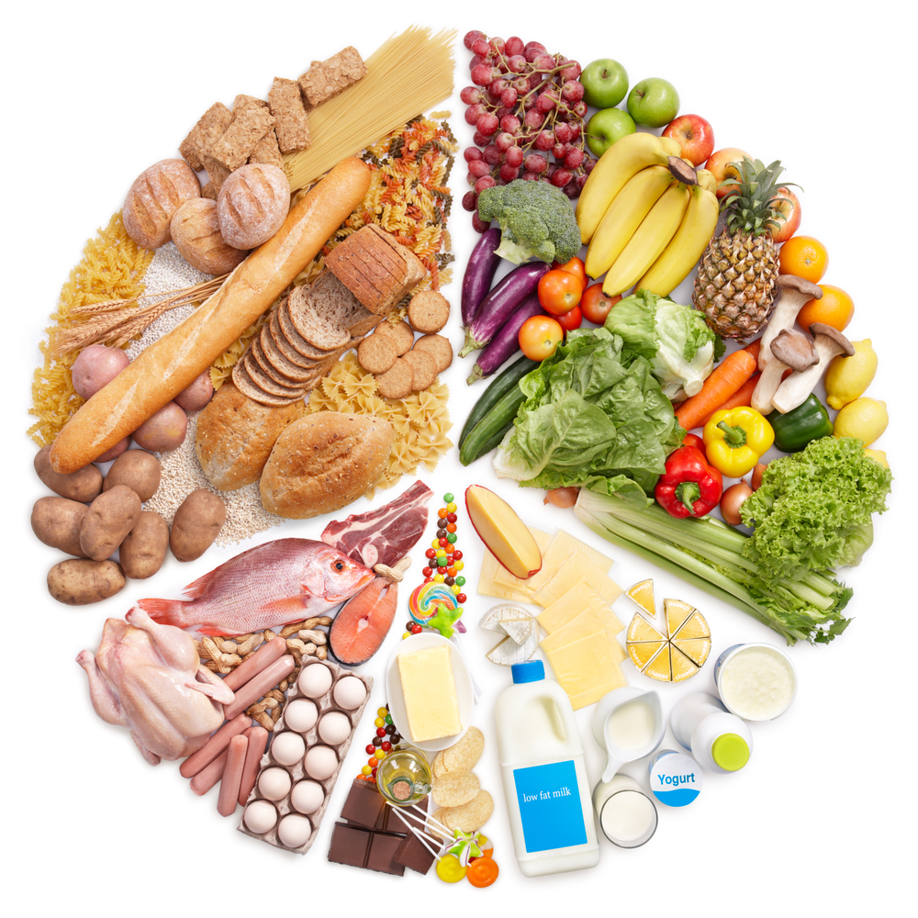
Quality is controlled by the following:
- Quality of the ingredients purchased
- Skill level of the staff preparing the menu items
- Using standard recipes
- Using portion control when placing food on plate
- Controlling and managing waste.

Staff Skill requirement
The skill level of the staff needs to be at a level to produce the food and serve to food to the required standard.
The staff employed must be capable of delivering the standard the menu requires.
Why people cook professionally?
- For some it is just a job and a way to earn an income
- For the professional it is a vocation from which they derive immense satisfaction.
They manipulate the food to develop and enhance the flavour to bring satisfaction to the consumers.
During the cooking process the food is treated so that digestibility is improved, made easier to eat and any potentially harmful bacteria or micro-organism.
Staff must be able to follow management instruction, be self organising and prepared to work with others to accomplish the required tasks.

Food ordering system
Ordering food required needs to be controlled so all that is ordered is used.
Modern day production in the kitchen does not allow for a side of lamb to be purchased and then have the cooks break down into usable portions.
Purchasing product with strict specification of how the product is to come to your premises.
Sirloin
- Cut 180gm each
- 3mm fat covering.
Lamb Cutlet
- 10cm bone
- Frenched
- Fat layer: 2mm.

Cooking food to a standard
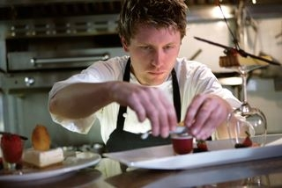
Cooking to the menu is difficult to achieve when customers want variation to suit their own personal taste.
Cooking to a Standard Recipe
Customers continue purchase product for various reasons. Main reason is they like the flavour.
Eating is a sensory delight for the majority of people so they will purchase a product if they like what they are eating.
Dining is an overall experience that includes the ambience of the surroundings in which the food is served:
- Level of service given when dining at an establishment
- Value for money perception from the dining experience.
For some people the cost can be a factor but for most it is the flavour and the enjoyment that is obtained from the whole experience.

Food Cost Factors
The trouble with buying food for a menu is that it usually has a limited shelf life.
Coupled with the fact that it can also be expensive, this places significant emphasis on the purchaser to make sure he/she orders exactly what is needed, as well as scheduling where and when it is required.
Factors which will affect purchasing include:
- Regular menu changes
- Slow moving dishes
- Diners’ fluctuating choices
- Staff not adhering to standard recipes
- Food wastage and theft.
A major factor in controlling food cost is the skill of the staff and how long it takes to complete the required task.

Portion control
- Portion control is imperative to costing
- All the portions must be the same size.
There are excellent examples of food portion control processes in place.
Example: Worldwide hamburger chains.
Classic hamburger
- Buns - all the same size for each specific product
- Meat Pattie - made to specific requirements
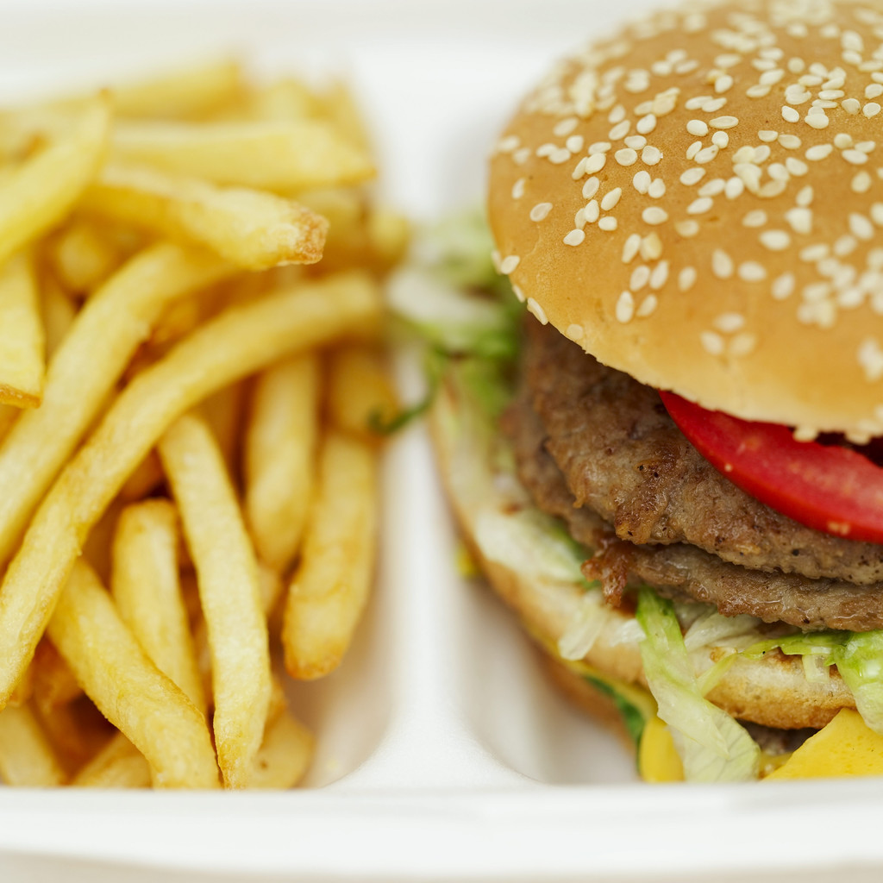
- Salad items per unit
- Size of tomatoes used
- Number of slices from each tomato
- 1 slice per burger
- Size of the slice of pickle - 1 or 2 slices per burger?
- Shredded lettuce per burger
- Number of seeds on each bun; average used due to handling loss
- Sauce used on each burger; measured.
Cooking of fries
- Set amount in each frozen packet
- Set temperature for cooking
- Automated cooking of fries
- Set time required before using so maximum amount of fat drains from product before serving to customers
- Special scoops that deliver set amount per serve and all sit the same in service container.
This is all about control
- Control of product that comes into premises and maximises the number of serves that served to customers
- Maximise profit.
Large function serves required the last meal to look like the first meal.
Waste reduction management
Reduction of waste from food production to minimise the impact on the environment.
What else can the off cut be used for to increase the earning potential of commodities purchased.
When product is purchased correctly then waste is minimised and profits is maximised.
Controlling stock levels minimises waste by reducing possibility of having out of date stock on hand.
Stock control management principle of first in first out (FIFO) along with only ordering what is required is the most the most effective tool to minimising potential waste in the kitchen.

2.2 Control labour costs

Labour Costs
Labour costs fall into two categories: direct and indirect labour costs.
Direct labour costs include all staff who have specifically prepared or served the food to the diners, i.e. chefs, waiting staff.
Indirect labour costs include all staff whose role supports overall operations.
These can include cleaners, sales departments, management and administration.
A commercial catering facility will normally incur both direct and indirect labour costs.
Labour costs are different in every country. Ensure compliance with all labour laws to avoid labour disputes and possible fines.
Factors which assist labour costs include is having a skilled labour force that can fulfil the requirements of the enterprise.
Conditions of employment and Rates of pay
Workers are generally happy and productive when they are compensated for their endeavours. Conditions vary from country to country.
What is common in Singapore may not be common in Thailand.
What workers get in an International Hotel may be different to a street café.
This includes established:
- Rates of pay, minimum rates per hour
- By the day
- By the week
- By the month
- Workers compensation; leave entitlements.
Enterprises and managers must ensure the appropriate award conditions and rates of pay are followed as a minimal guide, and rosters must reflect compliance with respective awards.
Student Activity
Research local requirements for conditions of work.
Write a report that informs the reader regarding likely cost that will be involved when employing staff.
- What are the responsibilities of the employer to protect the staff from injury?
- What benefits to staff that are employed by particular enterprises?
- What is the cost of employing staff - Cooks, waiters and cleaning staff?

2.3 Optimise product usage

Product utilisation
Even the most attractively written menus cannot be successful if products are not properly utilised or optimised.
An important underlying principle in menu planning should focus on product value and quality.
This can be achieved by effective portion control and effective yield testing.

Yield Testing
Good menu planning dictates that the kitchen staff will be able to utilise as much of the ingredients purchased as possible.
The following table lists a dish on the left column, and the main component required in the centre.
Column three lists the “leftovers” (components of the original ingredient), and column four lists suggestions as to how these ingredients can be used.
Dish | Main Ingredient | Leftovers | Suggested use
Baked Lobster Pie | Lobster flesh | Frame | Lobster bisque
Grilled Chicken Breasts | Whole chicken | Thighs  Winglets  Drumsticks  Frame | Thai curry  Stuffed and deep fried  Marinated and baked  Cream of chicken soup
Seared Hare Fillet | Hare | Hare thighs bones | Game terrine sauce for fillet
BBQ Sirloin steak | Sirloin plate | Trimmings (meat)  Trimmings (sinew, etc.) | Casserole, pies, etc.  Stock, sauces
Turned potatoes | Potatoes | Trimmed potato flesh | Mash, puree

Yield testing is not only understanding what to do with “leftovers”, but more about importantly knowing how much useable product you could reasonably expect to derive from an ingredient.
For example the yield of an average egg as laid by a hen is as follows:
- 30 percent egg yolk
- 60 percent egg white
- 10 percent shell.
If a recipe required liquid measurement of egg whites, the knowledge of the above yield test will help to determine exactly how many eggs are needed.

Rounding off when Calculating Figures
Rounding up or down is used when an answer gives more than the required decimal places.
To obtain the correct figure we must remove the excess figures:
For example:
- $1.678 = $1.68 All currency has 2 decimal places
- 5.684463 kg = 5.684 kg All weight measures have 3 decimal places
- 75.675% = 76% (For our entire exercises %’s have no decimal point).
Depending on the first figure being removed, we round up or down. If the figure is 5 or higher we round up, if 4 or lower no change.
For example:
- $1.678 we remove the 8 and round up to $1.68 because the figure is 5 or higher
- 5.684463 kg we remove 463 and remain the same 5.684 kg because the first figure is 4 or lower.

Pre-costing Dishes
Efficient cost control involves an overall awareness of the cost of ingredients, staff and other overheads.
As each establishment has different costing requirements, it is not feasible to suggest that any one costing system is preferable.
Each establishment does, however, take the following expenses into consideration:
- Cost of ingredients
- Labour cost
- Overheads.
If cooks are going to progress up the leadership ladder of the kitchen they are going to have to become involved in the business side of the profession.
What do ingredients cost and what can I do with leftover parts to increase the profit margin?
Student Activity
Write a descriptive menu for 2 dishes:
Break each dish into their elements
And cost each of the elements and arrive at a total food cost for the dish.
Example
Chicken Caesar Salad: Grilled chicken, cos lettuce, prosciutto, poached egg, parmesan, croutons, anchovies & house made dressing.
Chicken breast: ½ breast per salad
Lettuce: ¼ of a lettuce
Prosciutto: 30 gm
Poached egg: 1 egg
Croutons (8)
Caesar Dressing: 60g.
The dish is divided into its elements. These can now be costed and a price is arrived at:
What does it cost to produce this dish?
How much is charged will depend on management and its pricing policy. If a cook decided to use a whole chicken breast in a serve then the profit margin will be greatly affected.


Cost of Ingredients
This includes the cost of all ingredients used in the preparation and service of each dish.
When costing an individual dish, it is important that every ingredient is taken into consideration, including ingredients used in smaller amounts such as salt and pepper.
It should be kept in mind that these costs are variable for a number of reasons, such as seasonal and/or limited availability.

Labour Costs
Labour costs fall into two categories: direct and indirect labour costs.
- Direct labour costs include all staff who have specifically prepared or served the food to the diners, i.e. chefs, waiting staff
- Indirect labour costs include all staff whose role supports overall operations.
These can include cleaners, sales departments, management and administration.
A commercial catering facility will normally incur both direct and indirect labour costs.
Labour costs are considered fixed as hourly rates which are pre-established and directly offset against revenue.

Award Conditions and Rates
An “award” is a group of legally enforceable rules setting the minimal conditions under which employees can work.
This includes:
- Established rates of pay,
- Minimum and maximum hours workable,
- Allocation of breaks
- Types of leave that might apply to their employment contract.
Managers and/or chefs must ensure the appropriate award conditions and rates of pay are followed as a minimal guide, and rosters must reflect compliance with respective awards.

Overheads
Overheads include all expenses incurred in operating a business.
This includes all utilities such as power, water and gas.
It also includes payable tax, rates, cleaning, maintenance, insurance, leasing and rental costs.
In a hospitality establishment, this excludes the cost of ingredients and the labour component, which are costed separately.

2.4 Apply stock control measures

Receiving and storing

Important
- Correctly purchased goods will help maximise workplace efficiency and control menu-based costs.
The extent of the receiving and storing procedures will naturally vary depending on the establishment’s size and nature, and turnover.
For example, a small establishment will usually have the owner or chef responsible for the buying, receiving and storing of all foods.
This contrasts considerably with larger establishments that specifically employ staff to look after each section of the receiving and storing section, i.e. purchasing, stores officers, book keepers, cellar staff.
 |  |  |  |  |  | item/s in stock are issued
Start here |  |  |  |  |  | ⬆
item/s is required from store | ➔ | requisition/ order is raised | ➔ | requisition/order is approved | ➔ | requisition/ order is issued
⬆ |  |  |  |  |  | ⬇
⬆ | ⬅ | requisitioner is notified when item/s are out of stock or when item/s out of stock will arrive into store |  |  | ⬅ | item/s out of stock are ordered
⬆
⬇
 |  |  |  |  |  | supplier/s
Definition: What is Receiving?
The term “receiving” in the culinary industry means to receive food orders placed to suppliers, as well as ensuring they are accurate.
Definition: What is Storing?
Storing refers to the way the received food (or other products) are put away (stored) until required for use by the kitchen or other department.

Receiving and Checking Goods
On delivery of any product, the person responsible must ensure the delivery docket corresponds agrees with what is stated in the purchase order. The following areas are used to verify this.

Quantity
- Count and weigh all products
- Check the number or weight of items against the quantity ordered
- Know the weight of boxes or containers that the food is delivered in
- Familiarise yourself with quantities in which foods are packaged.

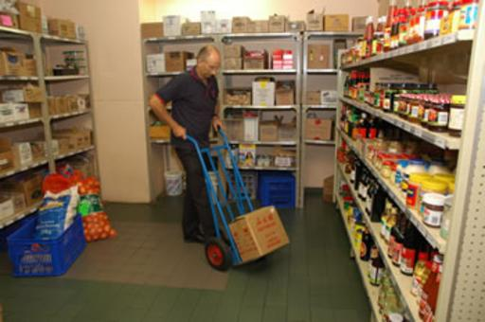
Size
- Check size specifications
- Packaging size may be incorrect:
- 600 ml cream containers sent instead of 300 ml.

Weight
- Weigh all goods delivered
- If there is a specific size for fresh product, it must be ensured that each size is similar.

Quality
- Check that frozen products are frozen
- Check use by dates
- Check the temperature of chilled product
- Check packaging for damage, rips, tears
- Check for signs of vermin
- Check tins for bloating (puffed look)
- Check that vacuum packed meats are still sealed.

Freshness
Each product has particular quality points that a good stores officer or chef will look for concerning freshness.
How do you determine is something is fresh?
- Smell
- Feel
- Visual; how it looks.

Order Forms

Good business practice dictates that all purchases are written down and recorded on an order form to ensure the delivery cross-references with what was originally ordered. In other words, it is a checking system. The procedure should be the same for each purchase:
- Specifications to the supplier
- Order to the supplier
- Delivery docket from the supplier
- Invoice from suppliers
- Statement from supplier.

Purchasing Specifications
Purchasing specifications are simply an agreement between the supplier and buyer to provide a product of a specified quality.
It is a detailed description of what you are buying, and minimises mistakes.
Order Form
Usually a printed form (in duplicate or triplicate) is completed to raise an order.
Delivery Docket
A form that accompanies ordered goods and is signed on receipt by the customer.
Invoice Docket
Used to accompany ordered goods sent to the customer. The signed original is given to the customer and the copy is retained by the supplier.
Statements
Provided by the supplier to account for goods provided (sold) over a given time, i.e. 14 days, one month, etc. showing the total amount payable.
Credit Notes
Supplied to the customer as a promised refund on any faulty returned products or overcharge.

Ordering Procedures: Pre-delivery
The supplier needs to know:
- Who is ordering the product
- Where it needs to go
- Date of delivery
- Time of delivery
- Product required
- Price.

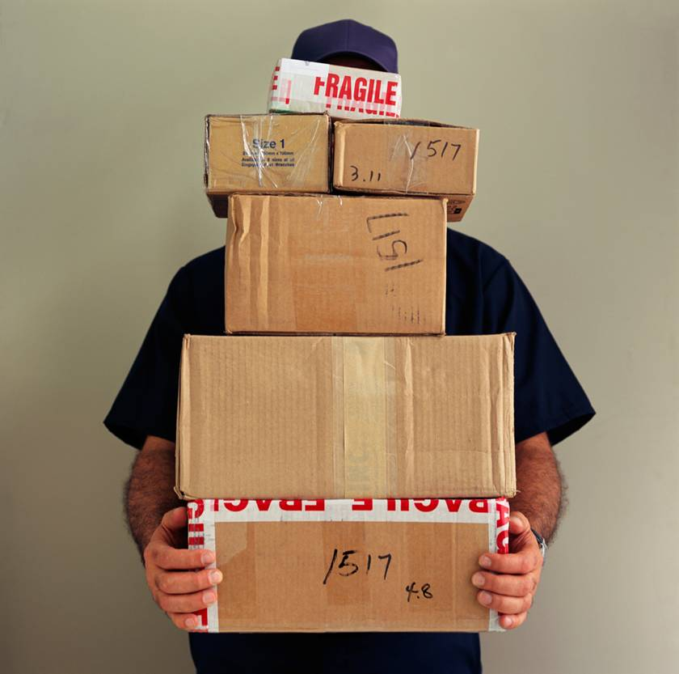
Delivery
On arrival, the delivery docket and order are cross-referenced to ensure they are identical. If there are any discrepancies, a credit note should be supplied.

Reporting Defects
When receiving goods from suppliers, all dockets need to be checked for accuracy. They should have the correct following information:
- Supplier’s name
- Docket number
- Date
- Credit or changes to order
- Signature required when accepting goods
- Prices
- Total prices
- All items itemised by quantity, weight, etc.
- Acceptable quality.
If any variations are noticed, they need to be reported. This can be achieved in a number of ways:
- Indicate on the delivery docket
- Have the delivery driver witness and initial it
- Notify the supplier immediately
- Request a prompt credit note.

Safe Lifting Procedures
When lifting heavy items, care should be taken that steps are taken to avoid injury and accidents. This can be achieved by following common sense lifting rules:
- If it looks too heavy, do not lift it. Get help
- Never bend from the waist only
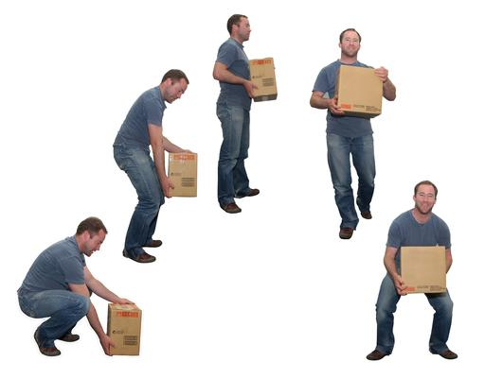
- Never lift heavy objects higher than your waist
- Avoid carrying awkward and/or unbalanced loads
- Hold heavy objects close to the body to obtain better leverage
- Where possible, use a hydraulic lifter or low trolley
- Never climb shelves (monkey style). Use ladders
- Ensure rooms are well lit
- Store all heavy objects low to the ground.

Storing Deliveries
Most products are delivered in some form of packaging, which requires you to consider and act upon the following:
- Remove and safely dispose of nails, staples and other sharp metallic objects from packing cases that may cause injury
- Use the correct tool to open specific containers, boxes, etc.
- Store heavier items on low shelves
- Keep all containers covered (lids) to keep out dust, insects and vermin including rats, mice and fleas
- Eliminate all loose or spilt foods to discourage insect and vermin from breeding
- Ensure all lights in stores areas have guards over them to prevent accidents
- Keep stores areas clean and tidy
- Do not use containers normally used for other purposes to hold food, i.e. Garbage bags for bread rolls, old bottles used to fill with detergent, etc.
Storage Space
Good food storage is reliant on three main factors:
- Sanitation
- Temperature
- Ventilation.

Sanitation
- High standards are essential for any food storage
- Clean shelving
- Surfaces (walls, ceilings, floors) to be free of cracks, paint flakes, etc.
- Stainless-steel shelving in the cool room
- Seals around doors to be kept clean and free from grime
- Active steps (traps) to deter rodents and insects
- Regular cleaning program.
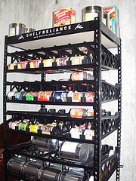
Temperature
- Correct temperature for different food groups
- Correct humidity levels
- Dry store approximately 15°C
- Cool room: 1° - 4°C
- Freezer: -18°C
- Temperatures to be monitored.
Ventilation
- Dry stores must be well ventilated
- Free from dampness
- Moderate humidity
- Good air circulation.

Food container storage
Some products, when received from suppliers, should be stored into correctly-labelled containers to avoid confusing one product from another, i.e. diced beef and diced lamb.
Dry goods, when opened from their original packets, need to be stored in containers with tight-fitting lids and low moisture content because grains, flours etc. will attract rodents, weevils and other insects.
All storage bins should be clearly labelled with the following:
- What the product is
- Date stored
- Quantity of product
- Par stock level (minimum and maximum stock level)
Refrigerated
Refrigerated products, i.e. meats, seafood should be placed in covered containers on racks to allow drainage and air circulation.
Frozen
Frozen products should be well wrapped and placed in plastic containers labelled with date, quantity and product to prevent freezer burn.

Specific food storage areas
Frozen Foods
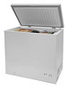
Upon receipt, frozen foods must be immediately stored to prevent thawing:
- Products should be segregated in to individual types, i.e. Vegetables, fruits, poultry, meat and seafood, etc.
- Temperature should be -18°C.
Note: Constant opening of the freezer doors will cause ice build-up.
Meat Refrigerator
- Should only be used for raw meats and must never be used for storing cooked foods, i.e. Cross-contamination
- Loose products should be placed on clean trays which are washed and sanitised daily
- Other raw meats, i.e. poultry, game, seafood can be stored together with meat, but care must be taken not to store them closely together
- Shelving, floors and walls must be regularly cleaned and disinfected to minimise bacterial growth
- All products must be on shelves to allow adequate air circulation.
Fruit and Vegetables
- Cool room should be cleaned daily.
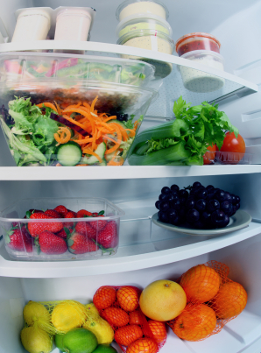
- Vegetables and fruits should be kept separated (loose soils on some vegetables can harbour bacteria and other micro-organisms)
- Polystyrene containers will insulate and maintain delicate green leafy herbs, etc.
- Most fruit and vegetable containers are suitable for storing in cool rooms
- The best temperature range for this area is between 5° - 10°C.
Dry Store
- The dry store is an area where non perishable, or long life items that do not require refrigeration, are stored. These products, however, will also damage if not handled carefully
- Stock must be rotated on a regular basis (as for all food items)
- Check for vermin, weevils in grains, etc.
- Ensure the area is well ventilated and lit
- Place all cartons on shelves, not on the floor or passages
- Maintain a temperature between 10° - 20°C.
Dairy Foods Refrigeration
- Dairy foods are highly absorbent and thus need to be stored away from strong smelling items (seafood, curries etc.)
- Maintain ideal temperature between 2° - 4°C
- Keep the room well cleaned to prevent mould, mildew and odours developing.
Student Activity
Revise the receiving and storing procedures in your place of work, then comment on the effectiveness of the following areas:
Receiving and storing procedures
Distribution of food from stores to kitchen areas
Recording procedures for stock transfer.
Try and approach this activity as if you were a consultant appointed to comment on receiving and storing.
Whilst you will be essentially analysing these activities, you should also be looking for ways to suggest improvements and/or efficiency.
Prepare your findings in the form of a report which includes the following areas:
- Introduction: state why this report is being prepared, and the areas being looked at
- Main Body: your observations (what you found), and your opinions about how a procedure was carried out
- Recommendation: comment on what could be improved by tying all the areas together by making an overall comment on procedures.
Keep the entire report to 500 words or less, and present it to your workplace supervisor and/or Trainer (preferably typed).
If you have answered NO to any of the above questions, ask your Trainer for help.
If you feel you do not fully understand an activity, repeat it.

Preventing Workplace Theft
Protecting a food production facility from theft and damage is one of the more common and expensive problems facing most establishments.
Theft occurs when materials or foods are taken from the workplace without proper authorisation by staff, patrons and/or outsiders.
Damage to a product occurs if it has been stored poorly, or in the wrong location. As with theft, loss of product from damage is both wasteful and preventable.
The challenge lies in sufficiently securing all products and materials in a cost-effective manner.

Theft can develop into a serious problem for an establishment if security measures are insufficient. This risk can be minimised by:
- Regular stocktaking
- Locking storage areas, or implementing alarm systems
- Providing areas for staff to store bags and other personal effects
- Proper receiving, storing procedures and accurate record keeping
- Spot checks on all access/egress points, including rubbish bins. (staff can use bins to remove food in sealed bags and access them later)
- Efficient staff monitoring
- Having sufficient documentation and authorisation for any stock required from the stores areas
- Transferring of food between departments is also recorded to monitor and account for stock movement.

Security
Security is the responsibility of all staff in the workplace. Predominant responsibilities include making sure that the property of customers is safe and secure from theft and loss. It also includes making sure that the establishment is similarly secured.
Dealing with Theft
It is important that all staff are encouraged to be on the lookout for potential theft or property damage by:
- Looking out for people who do not work at the establishment or look suspicious i.e. Loitering
- Noticing unusual activity
- Not allowing unauthorised people to walk through the establishment
- Locking storage areas securely as well as the kitchen when left unattended
- Controlling the issuing and storage of keys
- Installing alarms in storage areas after hours.
Staff should also be encouraged not to thwart a theft by themselves, but report it immediately. Emphasis should be placed on the policy of never accosting armed robbers in the workplace.

Dealing with Damage and Loss
- Being observant,
- Noticing poorly packed foods (damage)
- Products stored in the wrong areas, example; foods with chemicals
- Placing suitable storage procedures into place to avoid possible product damage
- Having designated staff authorised to transfer materials and stock from storage to production areas.
Student Activity
You are required to prepare a list of all the different ways that your establishment secures edible foods from theft.
Once this list has been compiled, you need to comment on its effectiveness.
If you were the owner, would you secure food differently? If so, why, and if not, why not?

Stock take
A stock take is one of the many tools at a chef’s disposal to help keep control of what is happening to the food within the establishment.
Why do a stock take:
- To establish an accurate overall food cost %

- To control stock
- To monitor sales
- To control wastage
- To control pilfering
- To control profits
- To control ordering/over ordering.
Who is responsible?
Large establishments:
- Executive chef
- Store manager.
Small establishment:
- Chef.

How a Stock take is conducted
A Stock take is something that is taken after a period of time. This will be determined by management and time will need to be allotted to conduct this task.
Care must be taken so that an accurate account can be achieved.
When an enterprise starts to operate they will be operating with food that is already purchased. This becomes a debit to the enterprise until the enterprise earns an income from the sale of the processed product.
This is found in the sales receipt from each day.
The example above is explained like this:
- There is established stock from previous trading time. This may be the end of the month of April
- A Stock take must be taken of what is on the premises before a food cost can be accomplished. This becomes the opening stock for the next trading period
- New stock is purchased for the trading month of May
- The last day of May will be the end of the trading period
- 1st day of June a stock take will be conducted for the trading month of May
- The stock in the storeroom on the 1st day of June will be the ‘closing stock’
- All the food purchased during the month of May will have had purchasing receipts that relate to these purchases
- Add all this purchases and this becomes Total of all stock purchases for the month of May.
To find the actual food cost percentage for a given period you need:
- Sales records - cash register, sales dockets
- Purchases - invoices, petty cash receipts
- Stock - freezer stock sheets, dry store record sheets, cool room records.
All stock must be counted every time a stock take is done, so records must be developed that show everything that is purchased.
Students are encouraged to start developing sheets for their own use.
When a product is purchased it must be written like this for Flour and the bag weighs 25kg.
Item | Qty | Unit | Value | Value per unit
Flour | 25 | Kg | $12.75 | $0.51
25 kilo of flour cost $12.75; this makes 1 kilo worth $0.51 per kilo.
If the recipe calls for 3.450 kilo of flour then a cost of $1.75 is attached to the cost of the flour.

Stock take Sheet
Date: | ____/____/____ |  |  |  | Trading Period |  | ______/___/___ > _____/___/_____
Conducted by |  |  | 1.________________
 |  |  | 2.________________ |  |  |  |  | Sheet No |  |  | 1 of 1
Item |  | Qty | Unit | Unit  Cost | Total  Value | Item |  | Qty |  | Unit | Unit  Cost |  | Total  Value
Beef |  |  |  |  |  | Fruit
Bones |  | 10.5 | kg | $ 2.25 | $ | Bananas |  |  |  |  | $ |  | $
Diced |  | 6 | kg | $ 3.45 | $ | Kiwifruit |  |  |  |  | $ |  | $
Rump |  | 4 | kg | $ 8.95 | $ | Strawberries |  |  |  |  | $ |  | $
Striploin |  | 6 | kg | $ 11.00 | $ | Mango |  |  |  |  | $ |  | $
Beef Fillet |  |  | kg | $ 26.00 | $ | Lemons |  |  |  |  | $ |  | $
Lamb/Goat |  |  |  |  | $ | Limes |  |  |  |  | $ |  | $
Diced |  | 2.5 | kg | $ 2.25 | $ |  |  |  |  |  | $ |  | $
Cutlets |  | 3.5 | kg | $ 2.25 | $ |  |  |  |  |  | $ |  | $
 |  |  |  |  | $ | Vegetables
 |  |  |  |  | $ | Carrot |  |  |  |  | $ |  | $
Pork |  |  |  |  |  | Onion |  |  |  |  | $ |  | $
Cutlets |  | 2 | kg | $ | $ | Cauliflower |  |  |  |  | $ |  | $
Diced |  | 5 | kg | $ | $ | Zucchini |  |  |  |  | $ |  | $
Mince |  | 5.5 | kg | $ | $ | Eggplant |  |  |  |  | $ |  | $
 |  |  |  | $ | $ | Garlic |  |  |  |  | $ |  | $
Chicken |  |  |  | $ | $ | Ginger |  |  |  |  | $ |  | $
Whole |  |  |  | $ | $ |  |  |  |  |  | $ |  | $
Breast |  |  |  | $ | $ | Herbs
Legs |  |  |  | $ | $ | Coriander |  |  |  |  | $ |  | $
 |  |  |  | $ | $ | Rosemary |  |  |  |  | $ |  | $
 |  |  |  | $ | $ | Lemongrass |  |  |  |  | $ |  | $
 |  |  |  | $ | $ | Parsley, Cont |  |  |  |  | $ |  | $
Dairy |  |  |  |  |  | Chives |  |  |  |  | $ |  | $
Milk |  |  | ltr | $ | $ |  |  |  |  |  | $ |  | $
Cream |  |  | ltr | $ | $ | Dry Goods
 |  |  |  | $ | $ | Rice |  |  |  |  | $ |  | $
Cheese |  |  |  | $ | $ | Flour |  |  |  |  | $ |  | $
Cheddar |  |  | kg | $ | $ | Sugar |  |  |  |  | $ |  | $
Blue |  |  | kg | $ | $ | Sugar, brown |  |  |  |  | $ |  | $
Brie |  |  | kg | $ | $ | Oil, Vegetable |  |  |  |  | $ |  | $
Camembert |  |  | kg | $ | $ | Oil, Olive |  |  |  |  | $ |  | $
Parmesan |  |  | kg | $ | $ | Oil, Rice bran |  |  |  |  | $ |  | $
 |  |  |  | $ | $ | Gelatine leaves |  |  |  |  | $ |  | $
 |  |  |  | $ | $ | Anchovies |  |  |  |  | $ |  | $
Small Goods |  |  |  | $ | $ |  |  |  |  |  | $ |  | $
Prosciutto |  |  | kg | $ | $ |  |  |  |  |  | $ |  | $
Salami |  |  | kg | $ | $ | Paper Goods
Ham |  |  | kg | $ | $ | Aluminium Foil |  |  |  |  | $ |  | $
Capacolo |  |  | kg | $ | $ | Plastic wrap |  |  |  |  | $ |  | $
 |  |  |  | $ | $ | Paper cups |  |  |  |  | $ |  | $
 |  |  |  | $ | $ |  |  |  |  |  | $ |  | $
 |  |  |  | $ | $ |  |  |  |  |  | $ |  | $
Total for this column |  |  |  |  | $ | Total for this column |  |  |  |  |  |  | $
 |  |  |  |  | Total Value for this page both columns |  |  |  |  |  |  |  | $
 |  |  |  |  |  |  |  |  |  |  |  |  | $

Students Stock take Sheet
Stock take Sheet
Rack/Shelf Number |  |  |  |  |  | Sheet |  | _______ of _________
Date: | _____/_______/________
 |  |  |  | Conducted by |  |  | 1.
 |  |  |  |  |  |  | 2.
Item |  | Qty |  | Unit |  |  | Unit price |  | Total Value
 |  |  |  |  |  |  | $ |  | $
 |  |  |  |  |  |  | $ |  | $
 |  |  |  |  |  |  | $ |  | $
 |  |  |  |  |  |  | $ |  | $
 |  |  |  |  |  |  | $ |  | $
 |  |  |  |  |  |  | $ |  | $
 |  |  |  |  |  |  | $ |  | $
 |  |  |  |  |  |  | $ |  | $
 |  |  |  |  |  |  | $ |  | $
 |  |  |  |  |  |  | $ |  | $
 |  |  |  |  |  |  | $ |  | $
 |  |  |  |  |  |  | $ |  | $
 |  |  |  |  |  |  | $ |  | $
 |  |  |  |  |  |  | $ |  | $
 |  |  |  |  |  |  | $ |  | $
 |  |  |  |  |  |  | $ |  | $
 |  |  |  |  |  |  | $ |  | $
 |  |  |  |  |  |  | $ |  | $
 |  |  |  |  |  |  | $ |  | $
 |  |  |  |  |  |  | $ |  | $
 |  |  |  |  |  |  | $ |  | $
 |  |  |  |  |  |  | $ |  | $
 |  |  |  |  |  |  | $ |  | $
 |  |  |  |  |  |  | $ |  | $
 |  |  |  |  |  |  | $ |  | $
 |  |  |  |  |  |  | $ |  | $
 |  |  |  |  |  |  | $ |  | $
 |  |  |  |  |  |  | $ |  | $
 |  |  |  |  |  |  | $ |  | $
 |  |  |  |  |  |  | $ |  | $
 |  |  |  |  |  |  | $ |  | $
 |  |  |  |  |  |  | $ |  | $
Total Value of Stock |  |  |  |  |  |  |  |  | $

2.5 Plan production schedules
Planning production schedules will differ from each enterprise.
- Function venue menu
- A la carte restaurant menu
- Aged care home menu.
All are designed to achieve the same end result. Control the required production of food.
Menu constraints
Menus in a la carte venues will have to rely on the law of averages.
- What was the number sold last night
- What was sold same day last week
- What sold last month same time.
Sometimes a dish will run out because it has been more popular than usual.
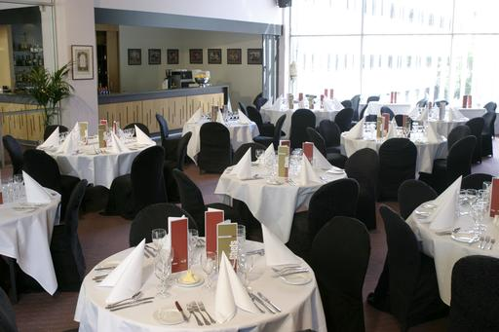
Function venue menus will have a variety of choices but when service comes around it is generally choice of:
- Two entrees
- Two main courses
- Two desserts.
All that is required to be known are the numbers of customers to be served
Aged care menus will be more basic with all clients eating the same food except for special diet needs; gluten intolerance; peanut allergies and similar eating disorders.
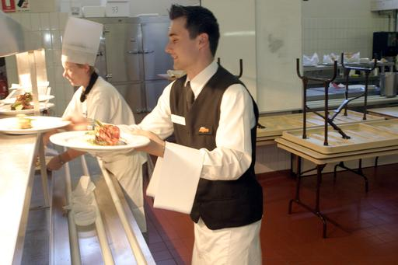
Service periods
Service periods and opening hours will be set
Aged care homes will have breakfast, lunch and dinner service periods set and some lighter snack periods set and will run on a daily basis with only minimal changes
Function venues will have intermittent service periods depending on the requirements of the customers.
A la carte restaurants will also have set times for service but what is the unknown will be the number of menu items that will be required for each service.

Special dietary specifications
Diet | Details
Low Lactose | Only very low levels of dairy products are suitable.  Soy products are generally acceptable.  No cream, yoghurt or milk-based sauces or dishes should be served.
Lactose Intolerant | No lactose is acceptable in any form.
Vegetarian | No meat, but all types of vegetables can be served.  Some vegetarians also eat seafood and a wide range of dairy products such as eggs, cheese, etc.
Vegan | More strict than some vegetarians. No meat or animal by-products at all.  This includes dairy products, butter, and cheese.  Generally food prepared in a vegetable or olive oil.
Renal Diet | This generally involves very low levels of sodium and potassium, subject to the individual’s requirements.  Low sodium means low salt.  Foods high in potassium, such as green leafy vegetables, must be avoided.
Gluten-Free Diets | Gluten is the protein found in cereal grain.  No food should be served containing flour.  Soya flour is generally acceptable.
Kosher Diets | Certain food types and preparation conforming to Jewish religious dietary law.  Level of requirement can vary according to strictness adopted by the individual.
Allergies | Persons may have allergies to specific products or groups of products.  No level of the allergen is acceptable.

General Comments
The above are just some examples of special dietary requirements.
Remember, all dietary requirements are individual.
To be safe it is important to investigate the very specific requirements in each instance.
Although restrictions generally outline what individuals cannot eat, it is often better to request specific details of what exactly an individual can eat, while staying in line with the general menu where possible.

Work Projects
It is a requirement of this Unit you complete Work Projects as advised by your Trainer.
You must submit documentation, suitable evidence or other relevant proof of completion of the project to your Trainer by the agreed date.
Suitable requirements for this unit may be a report that answers the following criteria.
A report that states what you will need to do to control the catering in your establishment.
2.1 Give a statement that outlines the range and type of establishment that you will be managing:
- Will it be a la carte or a set menu?
2.2. Control of labour costs.
- Write a roster and outline the number of staff that will be require to meet the food production requirements
- How many days per week will the business be operating; labour requirements for each day?
2.3. Control stock and optimise product usage.
- Write a set of procedures for ordering of stock required
- Produce a set of Standard recipes for the menu you have produced
- The stock ordered needs to reflect menu requirements.
2.4. Develop production schedules.
- The schedule must contain guidelines that relate to the production requirements envisaged
- What can be produced ahead of time?
- What has to be made on a daily basis?
- What mise en place needs to be produced for each dish?
The Trainer will make the final decision on what is required to demonstrate competency in this unit.
A professionally run Kitchen will have all menu items costed and a competent managing cook will have a good idea of how long it takes to produce a menu item or dish.
The cost of labour as well as ingredients needs to be applied before the on cost applied to the dish then the level of profit for the business can be applied to arrive at the desired selling price.

Summary

Manage menu-based catering
Select and use appropriate catering control
All stages of the production needs to be monitored and controlled.
Control labour costs
The largest expense in the kitchen is the labour cost. Having personnel standing around and being non-productive is a waste of money.
The same can be said of how long it takes a person to carry out a process or procedure in the kitchen.
Do you need to buy the whole chicken if you do not have a use for the legs?
If you do not have a use for the whole bird it can be more cost effective to just order the breast from the supplier.
Optimise product usage
Order only what is required
There may be some off cuts that may have to be utilised in other dishes
How can ingredients leftovers.
Apply stock control measures
Rotation of stock based on the ‘first in first out’ principle
Store food purchases under temperature control as required to maintain freshness and quality
In larger premise it is important to have people in charge of storage areas to ensure proper use of stock. Accidents; breakages and spillages, theft by internal staff and persons from other areas
All needs to be controlled.
Plan production schedules
What has to be produced on a daily basis?
What can be produced and stored securely until required?
How many staff will be required to produce required number of meal in service periods?
All these questions need to be answered when you plan a production schedule for any enterprise.

Presentation of written work

1. Introduction
It is important for students to present carefully prepared written work. Written presentation in industry must be professional in appearance and accurate in content. If students develop good writing skills whilst studying, they are able to easily transfer those skills to the workplace.

2. Style

Students should write in a style that is simple and concise. Short sentences and paragraphs are easier to read and understand. It helps to write a plan and at least one draft of the written work so that the final product will be well organised. The points presented will then follow a logical sequence and be relevant. Students should frequently refer to the question asked, to keep ‘on track’. Teachers recognise and are critical of work that does not answer the question, or is ‘padded’ with irrelevant material. In summary, remember to:
- Plan ahead
- Be clear and concise
- Answer the question
- Proofread the final draft.

3. Presenting Written Work
Types of written work
Students may be asked to write:
- Short and long reports
- Essays
- Records of interviews
- Questionnaires
- Business letters
- Resumes.
Format
All written work should be presented on A4 paper, single-sided with a left-hand margin. If work is word-processed, one-and-a-half or double spacing should be used. Handwritten work must be legible and should also be well spaced to allow for ease of reading. New paragraphs should not be indented but should be separated by a space. Pages must be numbered. If headings are also to be numbered, students should use a logical and sequential system of numbering.
Cover Sheet
All written work should be submitted with a cover sheet stapled to the front that contains:
- The student’s name and student number
- The name of the class/unit
- The due date of the work
- The title of the work
- The teacher’s name
- A signed declaration that the work does not involve plagiarism.
Keeping a Copy
Students must keep a copy of the written work in case it is lost. This rarely happens but it can be disastrous if a copy has not been kept.
Inclusive language
This means language that includes every section of the population. For instance, if a student were to write ‘A nurse is responsible for the patients in her care at all times’ it would be implying that all nurses are female and would be excluding male nurses.
Examples of appropriate language are shown on the right:
Mankind | Humankind
Barman/maid | Bar attendant
Host/hostess | Host
Waiter/waitress | Waiter or waiting staff

Recommended reading
Bailey, Adrian & Ortiz, Elisabeth Lambert; 2003; The book of ingredients, Michael Joseph
Coup, Bernadette; 2003, Mise en place: recipes and resources, Bernadette Coup
Cracknell.H,

Kaufmann.R; 2009 (3rd edition); Practical Professional Cookery; Cengage Learning
Dark .Graham, McLean. Deirdre & Weatherhead. Sarah; 2011 (2nd edition); Kitchen Operations 2nd Ed, Pearson Australia
Drysdale.John; 2008 (4th edition); Profitable Menu Planning; Prentice Hall
Graham Dark, Deirdre McLean & Sarah Weatherhead 2011; Kitchen Operations 2nd Ed; Published by Pearson Australia
Gregoire, Mary B; 2013 (8th edition); Foodservice organisations: a managerial and systems approach; Pearson
Feinstein. Andrew H, Stefanelli. John M; 2009 (2nd edition); Purchasing for Chefs: A Concise Guide; Wiley
H.L. Cracknell & R.J. Kaufman, Revised Third Edition, 1999; Practical Professional Cookery; Published by The Macmillan Press Ltd, UK
McLean.D,Satori.l, Walsh C&S; 2004;The Professional Cook’s book: Commercial Cookery; Tertiary Press
McWilliams, Margaret 2013, Food fundamentals, 10th ed, Pearson, Boston
McWilliams, Margaret 2013, Illustrated guide to food preparation, 11th ed, Pearson
McVety.P, Ware.B, Ware.C; 2

008 (3rd edition); Fundamentals of Menu Planning; Wiley
QA International; 2009; The Visual Food Lover's Guide: Includes essential information on how to buy, prepare and store over 1,000 types of food; John Wiley & Sons Inc
Scanlon.N; 2012 (4th edition); Catering Management; Wiley
The Culinary Institute of America (CIA); 2011 (9th edition); The Professional Chef; Wiley
Traster.Daniel; 2013; Foundations of Menu Planning; Prentice Hall
Wolke, Robert; 2005; What Einstien Told His Cook 2; W. W. Norton & Company

Trainee evaluation sheet

Plan and manage menu-based catering
The following statements are about the competency you have just completed.
Please tick the appropriate box | Agree | Don’t Know | Do Not Agree | Does Not Apply
There was too much in this competency to cover without rushing
Most of the competency seemed relevant to me
The competency was at the right level for me
I got enough help from my trainer
The amount of activities was sufficient
The competency allowed me to use my own initiative
My training was well-organised
My trainer had time to answer my questions
I understood how I was going to be assessed
I was given enough time to practice
My trainer feedback was useful
Enough equipment was available and it worked well
The activities were too hard for me

The best things about this unit were:

The worst things about this unit were:

The things you should change in this unit are:

Trainee Self-Assessment Checklist
As an indicator to your Trainer/Assessor of your readiness for assessment in this unit please complete the following and hand to your Trainer/Assessor.

Plan and manage menu-based catering
 |  | Yes | No*
Element 1: Plan and write menus
1.1 | Establish the enterprise and/or clients requirements for menu/s
1.2 | Write menus for enterprise operations
1.3 | Write menu ensuring menu balance
1.4 | Prepare menu costing
1.5 | Produce finished/final menu
Element 2: Manage menu-based catering
2.1 | Select and use appropriate catering control
2.2 | Control labour costs
2.3 | Optimise product usage
2.4 | Apply stock control measures
2.5 | Plan production schedules

Statement by Trainee:
I believe I am ready to be assessed on the following as indicated above:
Signed: | _____________________________ | Date: | ______ / ______ / ______
Note:
For all boxes where a No* is ticked, please provide details of the extra steps or work you need to do to become ready for assessment.

Appendix

Answers for Exercises to calculate food costs and food cost %
Exercise 1
Opening Stock $22,642.23 $19,957.64 $18,389.27 $17,599.83
Purchases $20,238.01 $17,345.23 $20,486.19 $22,565.94
Closing Stock $19,957.64 $18,389.27 $17,599.83 $18,982.93
Food Costs = $22,922.60 $18,913.60 $21,275.63 $21,182.84
Sales = $71,967.45 $69,364.56 $75,978.23 $71,013.08
Food Cost % = 31.85 % 27.27 % 28.00 % 29.83 %
Exercise 2
Opening Stock $24,161.23 $20,399.79 $18,891.55 $17,798.36
Purchases $16,986.64 $19,784.28 $20,124.89 $20,793.99
Closing Stock $20,399.79 $18,891.55 $17,798.36 $19,287.84
Food Costs = $20,748.08 $21,292.52 $21,218.08 $19,304.51
Sales = $74,508.74 $71,281.34 $68,897.95 $69,563.64
Food Cost % = 27.85 % 29.87 % 30.80 % 27.75 %
Exercise 3
Opening Stock $23,226.42 $20,238.01 $17,839.59 $18,939.82
Purchases $19,345.23 $18,273.89 $22,945.65 $20,287.84
Closing Stock $20,238.01 $17,839.59 $18,939.82 $19,737.86
Food Costs = $22,333.64 $20,672.31 $21,845.42 $19,489.80
Sales = $69,563.64 $70,012.84 $71,080.13 $69,094.48
Food Cost % = 32.11 % 29.53 % 30.73 % 28.21 %
Exercise 4
Opening Stock $20,793.99 $19,236.42 $21,011.55 $18,245.82
Purchases $20,010.64 $20,974.34 $18,739.59 $20,011.98
Closing Stock $19,236.42 $21,011.55 $18,245.82 $19,161.12
Food Costs = $21,568.21 $19,199.21 $21,505.32 $19,096.68
Sales = $71,459.67 $68,258.59 $69,879.36 $70,908.44
Food Cost % = 30.18 % 28.13 % 30.77 % 26.93 %

Answers for Exercises to calculate restaurant food cost

Exercise 1
At the Shining Sun Restaurant, stock take is done by the chef every three months to find the actual food cost %. The food cost % the kitchen aims to achieve is 33%.
Below is a table of information which the chef works out every month as a guide to find the food cost in relation to the actual sales made.
Some of the information is missing and you need to fill in the blank spaces.
Month | Food Cost $ | Sales $ | Food Cost %
January | 15071.84 | 45672.25 | 33%
February | 13438.86 | 40723.82 | 33%
March | 14709.28 | 44573.58 | 33%
Total | 43219.98 | 130969.65 | 33%
Now your task is to complete the three monthly stock take and find the actual food cost % using the information provided.
Opening Stock: $10694.28
Closing Stock: $8725.49
Purchases: See invoices
Opening Stock | 10694.28
Purchases | 45180.28
Total Stock | 55874.56
Closing Stock | 8725.49
Food Cost $ | 47149.07
Actual Food Cost % | 36%

Mac’s Meats Inc.
Invoice No: 96548521 |  | For the period beginning January 1
 |  | Ending: March 31st
January | $ 5826.70
February | $ 6273.35
March | $ 3363.02
Total | $15467.07
Fruit & Veg
Invoice No: 96548521 |  | For the period beginning January 1
 |  | Ending: March 31st
January | $ 4682.86
February | $ 3245.26
March | $ 4145.08
Total | $12063.20
Fine Foods
Invoice No: 456820 |  | For the period beginning January 1
 |  | Ending: March 31st
January | $ 3125.60
February | $ 3268.30
March | $ 2587.96
Total | $8981.86
Pluckas Poultry
Invoice No: 96548521 |  | For the period beginning January 1
 |  | Ending: March 31st
January | $ 3826.15
February | $ 2268.05
March | $ 2577.95
Total | $8672.15

Exercise 2
At the Main Road Restaurant, stock take is done by the chef every three months to find the actual food cost %. The food cost % the kitchen aims to achieve is 32.5%.
Below is a table of information which the chef works out every month as a guide to find the food cost in relation to the actual sales made.
Some of the information is missing and you need to fill in the blank spaces.
Month | Food Cost $ | Sales $ | Food Cost %
January | 15051.08 | 46311.02 | 32.5%
February | 11601.12 | 35695.74 | 32.5%
March | 12813.80 | 39427.07 | 32.5%
Total | 39466.00 | 121433.83 | 32.5%
Now your task is to complete the three monthly stock take and find the actual food cost % using the information provided.
Opening Stock: $9542.43
Closing Stock: $8122.13
Purchases: See invoices
Opening Stock | 9542.43
Purchases | 40170.79
Total Stock | 49713.22
Closing Stock | 8122.13
Food Cost $ | 41591.09
Actual Food Cost % | 34.25%

Mac’s Meats Inc.
Invoice No: 96548521 |  | For the period beginning January 1
 |  | Ending: March 31st
January | $ 4321.68
February | $ 3382.70
March | $ 3988.47
Total | $11693.85
Fruit & Veg
Invoice No: 96548521 |  | For the period beginning January 1
 |  | Ending: March 31st
January | $ 3548.20
February | $ 3672.80
March | $ 3444.22
Total | $10365.22
Fine Foods
Invoice No: 96548521 |  | For the period beginning January 1
 |  | Ending: March 31st
January | $4732.15
February | $5286.20
March | $2565.85
Total | $12634.20
Pluckas Poultry
Invoice No: 96548521 |  | For the period beginning January 1
 |  | Ending: March 31st
January | $2324.02
February | $1706.50
March | $1448.00
Total | $5478.52

Exercise 3
At the Very Good Restaurant, stock take is done by the chef every three months to find the actual food cost %. The food cost % the kitchen aims to achieve is 34%.
Below is a table of information which the chef works out every month as a guide to find the food cost in relation to the actual sales made.
Some of the information is missing and you need to fill in the blank spaces.
Month | Food Cost $ | Sales $ | Food Cost %
January | 28139.19 | 82762.32 | 34
February | 25649.21 | 75438.86 | 34
March | 25590.86 | 75267.22 | 34
Total | 79379.26 | 233468.40 | 34
Now your task is to complete the three monthly stock take and find the actual food cost % using the information provided.
Opening Stock: 22670.33
Closing Stock: 25234.42
Purchases: See invoices
Opening Stock | 22670.33
Purchases | 76340.10
Total Stock | 99010.43
Closing Stock | 25234.42
Food Cost $ | 73776.01
Actual Food Cost % | 31.6%

Mac’s Meats Inc.
Invoice No: 965423585 |  | For the period beginning January 1
 |  | Ending: March 31st
January | $ 9267.82
February | $ 10136.40
March | $ 6680.81
Total | $26085.03
Fruit & Veg
Invoice No: 96548521 |  | For the period beginning January 1
 |  | Ending: March 31st
January | $ 7263.85
February | $ 6428.72
March | $ 7132.23
Total | $20824.80
Fine Foods
Invoice No: 96548521 |  | For the period beginning January 1
 |  | Ending: March 31st
January | $ 6724.89
February | $ 9348.20
March | $ 4275.11
Total | $20348.20
Pluckas Poultry
Invoice No: 96548521 |  | For the period beginning January 1
 |  | Ending: March 31st
January | $ 3678.27
February | $ 2468.80
March | $ 2935.00
Total | $9082.07





